

**REPORT CO4I**



*GUI APPLICATION DEVELOPMENT*

*MICRO-PROJECT.*

**TOPIC: SCHOOL MANAGEMENT system.**

***-UNDER THE GUIDANCE OF***

***SHAFAAQUE Ma’am***

**M.H SABOO SIDDIK POLYTECHNIC**

**Presented by:**

|  |  |  |
| --- | --- | --- |
| SR.NO | ROLL NO | NAME |
| 1. | 19417 | SanskritiMahadik. |
| 2. | 19419 | Sarvesh Raikar. |
| 3. | 19420 | Rakhangi Arisha. |
| 4. | 19421 | Aamir Khan. |
| 5. | 20481 | Mustafa Ghadai. |



MAHARASHTRA STATE

BOARD OF TECHNICAL EDUCATION

CERTIFICATE

This is to certify that Mr./MS: Sanskriti Mahadik

Roll No: 19417 Enrollment No:1900020250

of Fourth Semester of Diploma in **Computer Engineering** of Institute **M. H. SabooSiddik Polytechnic** (Code**: 0002**) has completed their term work satisfactorily in course **GUI Application Development** (22034) for the academic year 2020 to 2021 as prescribed in the curriculum.

Place: Mumbai Date .........................

Exam. Seat No: .........................

Subject Teacher. Principal. Head of the Department.

**Seal of Institute**



MAHARASHTRA STATE

BOARD OF TECHNICAL EDUCATION

CERTIFICATE

This is to certify that Mr./MS: Sarvesh Raikar

Roll No: 19419 Enrollment No:1900020246

of Fourth Semester of Diploma in **Computer Engineering** of Institute **M. H. SabooSiddik Polytechnic** (Code**: 0002**) has completed their term work satisfactorily in course **GUI Application Development** (22034) for the academic year 2020 to 2021 as prescribed in the curriculum.

Place: Mumbai Date .........................

Exam. Seat No: .........................

Subject Teacher. Principal. Head of the Department.

**Seal of Institute**



MAHARASHTRA STATE

BOARD OF TECHNICAL EDUCATION

CERTIFICATE

This is to certify that Mr./MS: Arisha Rakhangi

Roll No: 19420 Enrollment No: 200002044

of Fourth Semester of Diploma in **Computer Engineering** of Institute **M. H. SabooSiddik Polytechnic** (Code**: 0002**) has completed their term work satisfactorily in course **GUI Application Development** (22034) for the academic year 2020 to 2021 as prescribed in the curriculum. 2000020496

Place: Mumbai Date .........................

Exam. Seat No: .........................

Subject Teacher. Principal. Head of the Department.

**Seal of Institute**



MAHARASHTRA STATE

BOARD OF TECHNICAL EDUCATION

CERTIFICATE

This is to certify that Mr./MS: Aamir Khan

Roll No: 19421 Enrollment No:1900020242

of Fourth Semester of Diploma in **Computer Engineering** of Institute **M. H. SabooSiddik Polytechnic** (Code**: 0002**) has completed their term work satisfactorily in course **GUI Application Development** (22034) for the academic year 2020 to 2021 as prescribed in the curriculum.

Place: Mumbai Date .........................

Exam. Seat No: .........................

Subject Teacher. Principal. Head of the Department.

**Seal of Institute**



MAHARASHTRA STATE

BOARD OF TECHNICAL EDUCATION

CERTIFICATE

This is to certify that Mr./MS: Mustafa Ghadia

Roll No: 20481 Enrollment No: 2000020496

of Fourth Semester of Diploma in **Computer Engineering** of Institute **M. H. SabooSiddik Polytechnic** (Code**: 0002**) has completed their term work satisfactorily in **GUI Application Development** (22034) for the academic year 2020 to 2021 as prescribed in the curriculum. 2000020496

Place: Mumbai Date .........................

Exam. Seat No: .........................

Subject Teacher. Principal. Head of the Department.

**Seal of Institute**

(Name and Signature of Faculty)

**ANNEXURE**

Evaluation sheet for the micro project

Academic Year: 2020-2021 Name of faculty: Shafaque Ma’am

Course: GUI Application Development (22034) Semester: IV

Title of the project: School Management System.

Cos addressed by Micro project:

A.

B.

Major learning outcomes achieved by students by doing the Project:  
(a)Practical outcomes.

(b)Unit outcomes in Cognitive domain

(c)Outcomes in effective domain

Comments/suggestions about teamwork/leadership/inter-personal communication (if any)

|  |  |  |  |  |
| --- | --- | --- | --- | --- |
| Roll no. | Student Name | Marks out of 6 for performance in group activity | Marks out of 4 for performance in oral/presentation | Total out of  10 |
| 19417 | Sanskriti Mahadik |  |  |  |
| 19419 | Sarvesh Raikar |  |  |  |
| 19420 | Arisha Rakhangi |  |  |  |
| 19421 | Aamir Khan |  |  |  |
| 20481 | Mustafa Ghadai |  |  |  |

***GAD MICRO-PROJECT REPORT***

*SCHOOL MANAGEMNET SYSTEM*

**Introduction: -**

Our project topic is School management system and our School name is Oxford School. Our aim was to make a GUI which can make it easier for the user to view our School Database , pay Fees and to enter new details through our GUI. Our project contains many other options like viewing blacklist students , giving feedback to teachers through feedback form , displaying result for individual student.These makes our project efficient and user friendly. This is more beneficial then our traditional way of school system as you can do get information about related to our school on one platform online

**GUI INTERFACE :-**

**There are various tabs provided for the user the tab information are as follows :**

1. The tab “teachers info” helps you to view details for both teaching staff and the non-teaching staff .select one among both , if you select anyone of the staff type you will available to see teachers/non-teaching staff name ,contact number ,designation etc
2. The tab “student info” provides the information regarding the student by selecting the “STD” of the student .It Shows details such GR.no , Roll.no ,StudentName,MotherName,FatherName,Religion,Address,Percentage,Attenance .There is also an option to add new details of a student
3. “Blacklist” options shows us the Students whose Attendance is less than 75% or below from last month of the selected STD
4. “Result ” tab shows the result of a particular student on the basis of Roll.no entered by the User. It displays the Marks of all the subject of that standard and the percentage .This feature helps the student to view their result online rather than coming to school to see their marks
5. To view whether a particular student has Paid its Fees Or Not , The “fees info” Tab is used . Select The Std and Fees type(PAID/NOT PAID) and you will see list of students for that type and standard.
6. The Student can pay his fees online through our website rather than going to their respective bank , There is an option for fees payment on the school website which is secured and safe payment mode, User only has to enter details such as Their name, Roll.no, Gr.no, Std, UPI id , UPI password It also provides one more step of security which is the OTP which will generated on the user mobile number .
7. Many Student have Complaint regarding a particular teacher or the management ,This Thing has been resolved by providing the Student a Complaint form . student has to input their name and write their complaint regarding the school. These complaints will be seen by the Admin and action will be taken regarding the complaint by the school authority
8. To Ensure whether the school teachers are teaching properly . Student has the option to fill the feedback form and to rate them based on some questions for a particular teacher, Such forms helps the school authority to know whether the students are understanding concepts properly or is there any issue regarding a teacher.

**We have used several concepts of vb.net to make our GUI user friendly. Like we have used progress bars to make our project more systematic. We have used picture boxes to create a graphical representation of the task the user can perform. We have inserted many other tools in our forms to make our form effective.**

**Message boxes are inserted and called after every step so that user can get the confirmation that his/her task has there is some error or it is successfully complete. For example, is a user tries to pay fees, then after the payment is done then a message box will show up as “successful fees payment.**

**We have also used error providers so that the user can understand the errors which he/she has done filling the forms. The errors are if any field is left which is mandatory to fill or the value in the field is not acceptable. For example, if the user forgets to write the name on any from then an error pop up.**

**We have used OLEDB provider to connect our access database with our forms. Then used data sets, adapters, commands and readers to perform many tasks. We have also used data binding concept in our project to connect our list box with data base. We have performed both simple and complex binding.**

***LOGIN FORM: -***

Code:

Public Class Login

Dim str As String

Private Sub Login_Load(sender As Object, e As EventArgs) Handles MyBase.Load

Me.WindowState = FormWindowState.Maximized

Panel1.Location = New System.Drawing.Point((Me.Width / 2) - (Panel1.Width / 2), (Me.Height / 2) - (Panel1.Height / 2))

Label6.Location = New Point(630, 600)

End Sub

Private Sub Label7_Click(sender As Object, e As EventArgs) Handles Label7.Click

If TextBox1.Text = "Anonymous@gmail.com" And TextBox2.Text = "I KNOW I M AWESOME" Then

ProgressBar1.Show()

ProgressBar1.Minimum = 0

ProgressBar1.Maximum = 200

ProgressBar1.Value = 0

ProgressBar1.Step = 10

Dim i As Integer

For i = 0 To 200

ProgressBar1.Value += ProgressBar1.Step

If ProgressBar1.Value = 200 Then

MsgBox("Sign in successfully", 0, "Sign in Status")

Home.Show()

Exit For

End If

Next

Else

MsgBox("Invalid Username or Password", 0, "Sign in Status")

End If

End Sub

Private Sub TextBox2_TextChanged(sender As Object, e As EventArgs) Handles TextBox2.TextChanged

If TextBox2.Text = "" Then

ErrorProvider1.SetError(TextBox2, "Please Enter Password")

ElseIf TextBox2.TextLength < 5 Then

ErrorProvider1.SetError(TextBox2, "Password Should have more than 4 Characters")

ElseIf TextBox2.TextLength > 20 Then

ErrorProvider1.SetError(TextBox2, "Password Should have Less than 20 Characters")

End If

' e.cancel = True

End Sub

Private Sub Label1_Click(sender As Object, e As EventArgs) Handles Label1.Click

Me.Close()

End Sub

Private Sub CheckBox1_CheckedChanged(sender As Object, e As EventArgs) Handles CheckBox1.CheckedChanged

str = TextBox1.Text

End Sub

Private Sub Label5_Click(sender As Object, e As EventArgs) Handles Label5.Click

If str.Length <> 0 Then

MsgBox("I Thing your Password is {0}", str)

End If

End Sub

Private Sub TextBox1_TextChanged(sender As Object, e As EventArgs) Handles TextBox1.TextChanged

If TextBox1.Text = "" Then

ErrorProvider1.SetError(TextBox1, "Please Enter Email")

End If

Dim EXPRESSION As New System.Text.RegularExpressions.Regex("\S+@\S+.\S")

If EXPRESSION.IsMatch(TextBox1.Text) Then

ErrorProvider1.SetError(TextBox1, "")

Else

ErrorProvider1.SetError(TextBox1, "Invalid Gmail")

End If

End Sub

Private Sub ProgressBar1_Click(sender As Object, e As EventArgs) Handles ProgressBar1.Click

End Sub

End Class

Output:

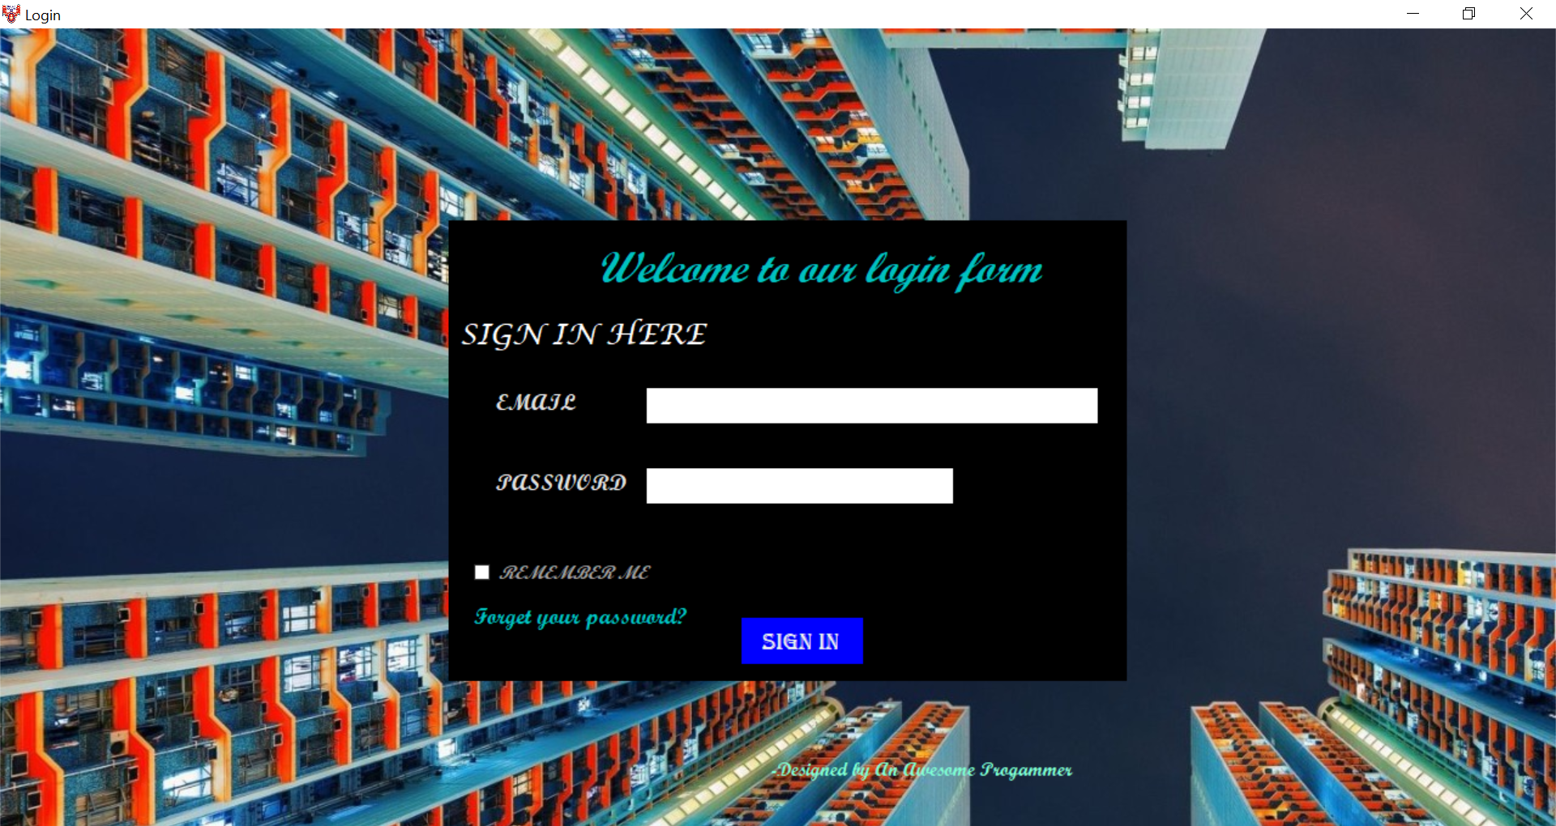

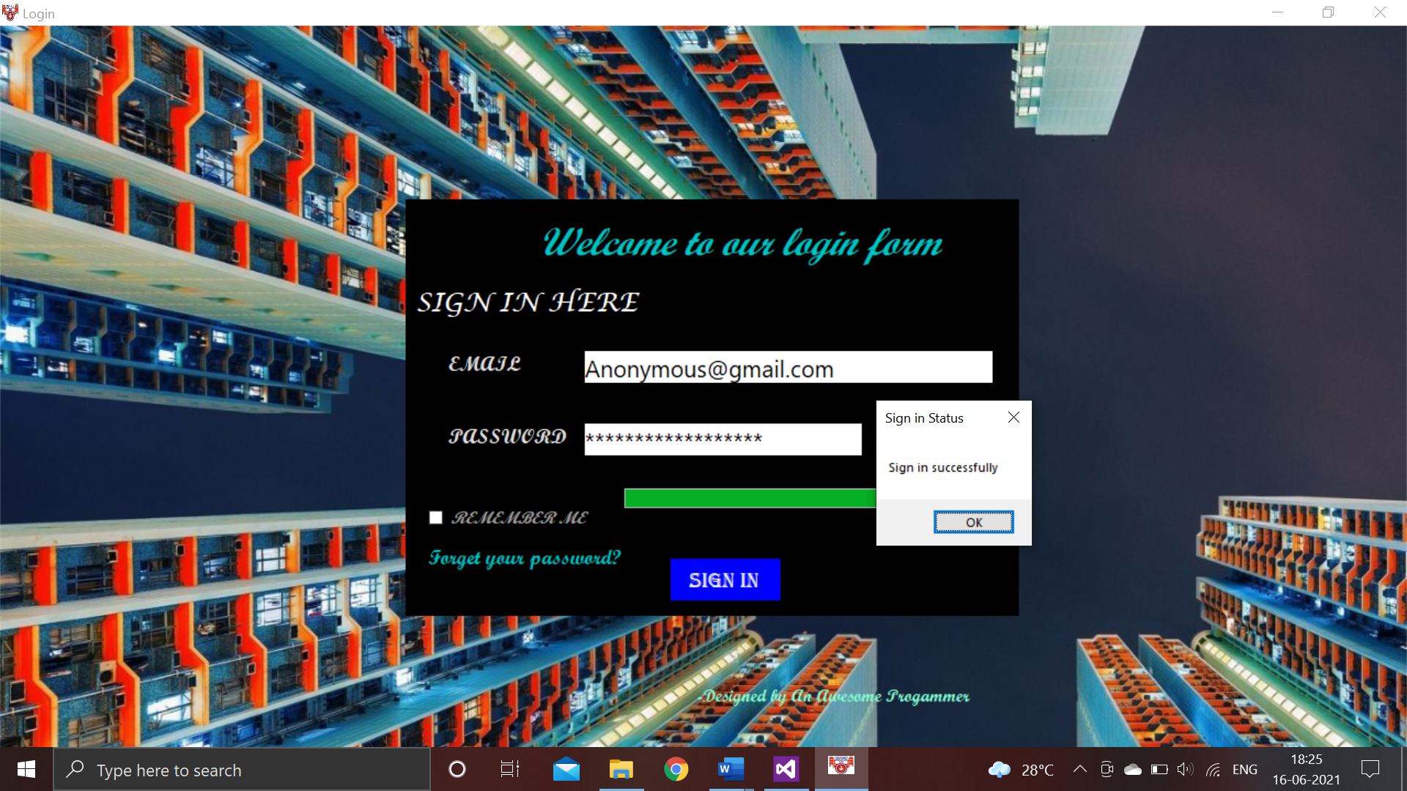

***HOME FORM: -***

Code:

Public Class Home

Private Sub Form1_Load(sender As Object, e As EventArgs) Handles MyBase.Load

Me.WindowState = FormWindowState.Maximized

End Sub

Private Sub Button4_Click(sender As Object, e As EventArgs) Handles Button4.Click

Student.Show()

End Sub

Private Sub Button1_Click(sender As Object, e As EventArgs) Handles Button1.Click

StaffInfo.Show()

End Sub

Private Sub Button5_Click(sender As Object, e As EventArgs) Handles Button5.Click

BlackList.Show()

End Sub

Private Sub Button6_Click(sender As Object, e As EventArgs) Handles Button6.Click

Result.Show()

End Sub

Private Sub Button7_Click(sender As Object, e As EventArgs) Handles Button7.Click

Fees.Show()

End Sub

Private Sub Button8_Click(sender As Object, e As EventArgs) Handles Button8.Click

FeesPayment.Show()

End Sub

Private Sub Button9_Click(sender As Object, e As EventArgs) Handles Button9.Click

Complaint.Show()

End Sub

Private Sub Button10_Click(sender As Object, e As EventArgs) Handles Button10.Click

Feedback.Show()

End Sub

Private Sub Button3_Click(sender As Object, e As EventArgs) Handles Button3.Click

h.Show()

End Sub

End Class

Output:

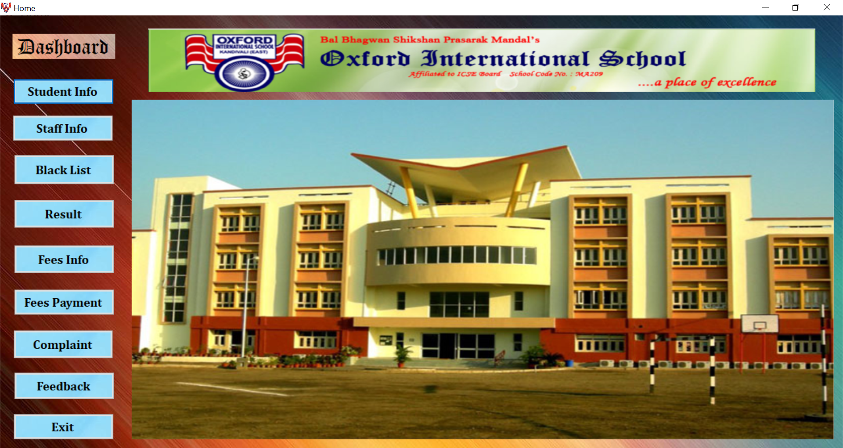

***STUDENT INFORMATION FORM: -***

Main Form:

Code:

Public Class Student

Private Sub Form1_Load(sender As Object, e As EventArgs) Handles MyBase.Load

Me.WindowState = FormWindowState.Maximized

End Sub

Private Sub Button1_Click(sender As Object, e As EventArgs) Handles Button1.Click

If RadioButton1.Checked Then

Std1.Show()

End If

If RadioButton2.Checked Then

Std2.Show()

End If

If RadioButton3.Checked Then

Std3.Show()

End If

If RadioButton4.Checked Then

Std4.Show()

End If

If RadioButton5.Checked Then

Std5.Show()

End If

If RadioButton11.Checked Then

Std10.Show()

End If

If RadioButton12.Checked Then

Std9.Show()

End If

If RadioButton13.Checked Then

Std8.Show()

End If

If RadioButton14.Checked Then

Std7.Show()

End If

If RadioButton15.Checked Then

Std6.Show()

End If

End Sub

End Class

Standard I Form:

Code:

Imports System.Data.OleDb

Public Class Std1

Private Sub Stud_Load(sender As Object, e As EventArgs) Handles MyBase.Load

'TODO: This line of code loads data into the 'STUDENTDataSet6.Std_I' table. You can move, or remove it, as needed.

Me.Std_ITableAdapter.Fill(Me.STUDENTDataSet6.Std_I)

Me.WindowState = FormWindowState.Maximized

End Sub

Private Sub Button1_Click(sender As Object, e As EventArgs) Handles Button1.Click

StdIBindingSource.MoveNext()

End Sub

Private Sub Button5_Click(sender As Object, e As EventArgs) Handles Button5.Click

StdIBindingSource.RemoveCurrent()

MessageBox.Show("RECORD IS DELETED")

End Sub

Private Sub Button2_Click(sender As Object, e As EventArgs) Handles Button2.Click

If TextBox13.Text = "" Or TextBox14.Text = "" Or TextBox15.Text = "" Or TextBox16.Text = "" Or TextBox17.Text = "" Or TextBox18.Text = "" Or TextBox19.Text = "" Or TextBox20.Text = "" Or TextBox21.Text = "" Or TextBox22.Text = "" Or TextBox23.Text = "" Or TextBox24.Text = "" Then

Call notFound()

Else

StdIBindingSource.EndEdit()

Std_ITableAdapter.Update(STUDENTDataSet6.Std_I)

MessageBox.Show("RECORD IS SAVE")

End If

End Sub

Private Sub Button3_Click(sender As Object, e As EventArgs) Handles Button3.Click

StdIBindingSource.AddNew()

End Sub

Private Sub Button4_Click(sender As Object, e As EventArgs) Handles Button4.Click

StdIBindingSource.MovePrevious()

End Sub

Private Sub notFound()

MsgBox("Please Enter Correct Details!!!!! ")

End Sub

End Class

Standard II Form:

Code:

Public Class Std2

Private Sub Std2_Load(sender As Object, e As EventArgs) Handles MyBase.Load

'TODO: This line of code loads data into the 'STUDENTDataSet8.Std_II' table. You can move, or remove it, as needed.

Me.Std_IITableAdapter.Fill(Me.STUDENTDataSet8.Std_II)

Me.WindowState = FormWindowState.Maximized

End Sub

Private Sub Button1_Click_1(sender As Object, e As EventArgs) Handles Button1.Click

StdIIBindingSource.MoveNext()

End Sub

Private Sub Button4_Click_1(sender As Object, e As EventArgs) Handles Button4.Click

StdIIBindingSource.MovePrevious()

End Sub

Private Sub Button3_Click_1(sender As Object, e As EventArgs) Handles Button3.Click

StdIIBindingSource.AddNew()

End Sub

Private Sub Button2_Click_1(sender As Object, e As EventArgs) Handles Button2.Click

If TextBox13.Text = "" Or TextBox14.Text = "" Or TextBox15.Text = "" Or TextBox16.Text = "" Or TextBox17.Text = "" Or TextBox18.Text = "" Or TextBox19.Text = "" Or TextBox20.Text = "" Or TextBox21.Text = "" Or TextBox22.Text = "" Or TextBox23.Text = "" Or TextBox24.Text = "" Then

Call notFound()

Else

StdIIBindingSource.EndEdit()

Std_IITableAdapter.Update(STUDENTDataSet8.Std_II)

MessageBox.Show("RECORD IS SAVE")

End If

End Sub

Private Sub Button5_Click_1(sender As Object, e As EventArgs) Handles Button5.Click

StdIIBindingSource.RemoveCurrent()

MessageBox.Show("RECORD IS DELETED")

End Sub

Private Sub notFound()

MsgBox("Please Enter Correct Details!!!!! ")

End Sub

End Class

Standard III Form:

Code:

Public Class Std3

Private Sub Std3_Load(sender As Object, e As EventArgs) Handles MyBase.Load

'TODO: This line of code loads data into the 'STUDENTDataSet5.Std_III' table. You can move, or remove it, as needed.

Me.Std_IIITableAdapter.Fill(Me.STUDENTDataSet5.Std_III)

Me.WindowState = FormWindowState.Maximized

End Sub

Private Sub Button1_Click(sender As Object, e As EventArgs) Handles Button1.Click

StdIIIBindingSource.MoveNext()

End Sub

Private Sub Button5_Click(sender As Object, e As EventArgs) Handles Button5.Click

StdIIIBindingSource.RemoveCurrent()

MessageBox.Show("RECORD IS DELETED")

End Sub

Private Sub Button2_Click(sender As Object, e As EventArgs) Handles Button2.Click

If TextBox13.Text = "" Or TextBox14.Text = "" Or TextBox15.Text = "" Or TextBox16.Text = "" Or TextBox17.Text = "" Or TextBox18.Text = "" Or TextBox19.Text = "" Or TextBox20.Text = "" Or TextBox21.Text = "" Or TextBox22.Text = "" Or TextBox23.Text = "" Or TextBox24.Text = "" Then

Call notFound()

Else

StdIIIBindingSource.EndEdit()

Std_IIITableAdapter.Update(STUDENTDataSet5.Std_III)

MessageBox.Show("RECORD IS SAVE")

End If

End Sub

Private Sub Button3_Click(sender As Object, e As EventArgs) Handles Button3.Click

StdIIIBindingSource.AddNew()

End Sub

Private Sub Button4_Click(sender As Object, e As EventArgs) Handles Button4.Click

StdIIIBindingSource.MovePrevious()

End Sub

Private Sub notFound()

MsgBox("Please Enter Correct Details!!!!! ")

End Sub

End Class

Standard IV Form:

Code:

Public Class Std4

Private Sub Std4_Load(sender As Object, e As EventArgs) Handles MyBase.Load

'TODO: This line of code loads data into the 'STUDENTDataSet7.Std_IV' table. You can move, or remove it, as needed.

Me.Std_IVTableAdapter.Fill(Me.STUDENTDataSet7.Std_IV)

Me.WindowState = FormWindowState.Maximized

End Sub

Private Sub Button1_Click(sender As Object, e As EventArgs) Handles Button1.Click

StdIVBindingSource.MoveNext()

End Sub

Private Sub Button5_Click(sender As Object, e As EventArgs) Handles Button5.Click

StdIVBindingSource.RemoveCurrent()

MessageBox.Show("RECORD IS DELETED")

End Sub

Private Sub Button2_Click(sender As Object, e As EventArgs) Handles Button2.Click

If TextBox13.Text = "" Or TextBox14.Text = "" Or TextBox15.Text = "" Or TextBox16.Text = "" Or TextBox17.Text = "" Or TextBox18.Text = "" Or TextBox19.Text = "" Or TextBox20.Text = "" Or TextBox21.Text = "" Or TextBox22.Text = "" Or TextBox23.Text = "" Or TextBox24.Text = "" Then

Call notFound()

Else

StdIVBindingSource.EndEdit()

Std_IVTableAdapter.Update(STUDENTDataSet7.Std_IV)

MessageBox.Show("RECORD IS SAVE")

End If

End Sub

Private Sub Button3_Click(sender As Object, e As EventArgs) Handles Button3.Click

StdIVBindingSource.AddNew()

End Sub

Private Sub Button4_Click(sender As Object, e As EventArgs) Handles Button4.Click

StdIVBindingSource.MovePrevious()

End Sub

Private Sub notFound()

MsgBox("Please Enter Correct Details!!!!! ")

End Sub

End Class

Standard V Form:

Code:

Public Class Std5

Private Sub Std5_Load(sender As Object, e As EventArgs) Handles MyBase.Load

'TODO: This line of code loads data into the 'STUDENTDataSet9.Std_V' table. You can move, or remove it, as needed.

Me.Std_VTableAdapter.Fill(Me.STUDENTDataSet9.Std_V)

Me.WindowState = FormWindowState.Maximized

End Sub

Private Sub Button1_Click(sender As Object, e As EventArgs) Handles Button1.Click

StdVBindingSource.MoveNext()

End Sub

Private Sub Button5_Click(sender As Object, e As EventArgs) Handles Button5.Click

StdVBindingSource.RemoveCurrent()

MessageBox.Show("RECORD IS DELETED")

End Sub

Private Sub Button2_Click(sender As Object, e As EventArgs) Handles Button2.Click

If TextBox13.Text = "" Or TextBox14.Text = "" Or TextBox15.Text = "" Or TextBox16.Text = "" Or TextBox17.Text = "" Or TextBox18.Text = "" Or TextBox19.Text = "" Or TextBox20.Text = "" Or TextBox21.Text = "" Or TextBox22.Text = "" Or TextBox23.Text = "" Or TextBox24.Text = "" Then

Call notFound()

Else

StdVBindingSource.EndEdit()

Std_VTableAdapter.Update(STUDENTDataSet9.Std_V)

MessageBox.Show("RECORD IS SAVE")

End If

End Sub

Private Sub Button3_Click(sender As Object, e As EventArgs) Handles Button3.Click

StdVBindingSource.AddNew()

End Sub

Private Sub Button4_Click(sender As Object, e As EventArgs) Handles Button4.Click

StdVBindingSource.MovePrevious()

End Sub

Private Sub notFound()

MsgBox("Please Enter Correct Details!!!!! ")

End Sub

End Class

Standard VI Form:

Code:

Public Class Std6

Private Sub Std6_Load(sender As Object, e As EventArgs) Handles MyBase.Load

'TODO: This line of code loads data into the 'STUDENTDataSet11.Std_VI' table. You can move, or remove it, as needed.

Me.Std_VITableAdapter.Fill(Me.STUDENTDataSet11.Std_VI)

Me.WindowState = FormWindowState.Maximized

End Sub

Private Sub Button1_Click(sender As Object, e As EventArgs) Handles Button1.Click

StdVIBindingSource.MoveNext()

End Sub

Private Sub Button5_Click(sender As Object, e As EventArgs) Handles Button5.Click

StdVIBindingSource.RemoveCurrent()

MessageBox.Show("RECORD IS DELETED")

End Sub

Private Sub Button2_Click(sender As Object, e As EventArgs) Handles Button2.Click

If TextBox13.Text = "" Or TextBox14.Text = "" Or TextBox15.Text = "" Or TextBox16.Text = "" Or TextBox17.Text = "" Or TextBox18.Text = "" Or TextBox19.Text = "" Or TextBox20.Text = "" Or TextBox21.Text = "" Or TextBox22.Text = "" Or TextBox23.Text = "" Or TextBox24.Text = "" Then

Call notFound()

Else

StdVIBindingSource.EndEdit()

Std_VITableAdapter.Update(STUDENTDataSet11.Std_VI)

MessageBox.Show("RECORD IS SAVE")

End If

End Sub

Private Sub Button3_Click(sender As Object, e As EventArgs) Handles Button3.Click

StdVIBindingSource.AddNew()

End Sub

Private Sub Button4_Click(sender As Object, e As EventArgs) Handles Button4.Click

StdVIBindingSource.MovePrevious()

End Sub

Private Sub notFound()

MsgBox("Please Enter Correct Details!!!!! ")

End Sub

End Class

Standard VII Form:

Code:

Public Class Std7

Private Sub Std7_Load(sender As Object, e As EventArgs) Handles MyBase.Load

'TODO: This line of code loads data into the 'STUDENTDataSet12.Std_VII' table. You can move, or remove it, as needed.

Me.Std_VIITableAdapter.Fill(Me.STUDENTDataSet12.Std_VII)

Me.WindowState = FormWindowState.Maximized

End Sub

Private Sub Button1_Click(sender As Object, e As EventArgs) Handles Button1.Click

StdVIIBindingSource.MoveNext()

End Sub

Private Sub Button5_Click(sender As Object, e As EventArgs) Handles Button5.Click

StdVIIBindingSource.RemoveCurrent()

MessageBox.Show("RECORD IS DELETED")

End Sub

Private Sub Button2_Click(sender As Object, e As EventArgs) Handles Button2.Click

If TextBox13.Text = "" Or TextBox14.Text = "" Or TextBox15.Text = "" Or TextBox16.Text = "" Or TextBox17.Text = "" Or TextBox18.Text = "" Or TextBox19.Text = "" Or TextBox20.Text = "" Or TextBox21.Text = "" Or TextBox22.Text = "" Or TextBox23.Text = "" Or TextBox24.Text = "" Then

Call notFound()

Else

StdVIIBindingSource.EndEdit()

Std_VIITableAdapter.Update(STUDENTDataSet12.Std_VII)

MessageBox.Show("RECORD IS SAVE")

End If

End Sub

Private Sub Button3_Click(sender As Object, e As EventArgs) Handles Button3.Click

StdVIIBindingSource.AddNew()

End Sub

Private Sub Button4_Click(sender As Object, e As EventArgs) Handles Button4.Click

StdVIIBindingSource.MovePrevious()

End Sub

Private Sub notFound()

MsgBox("Please Enter Correct Details!!!!! ")

End Sub

End Class

Standard VIII Form:

Code:

Public Class Std8

Private Sub Std8_Load(sender As Object, e As EventArgs) Handles MyBase.Load

'TODO: This line of code loads data into the 'STUDENTDataSet13.Std_VIII' table. You can move, or remove it, as needed.

Me.Std_VIIITableAdapter.Fill(Me.STUDENTDataSet13.Std_VIII)

Me.WindowState = FormWindowState.Maximized

End Sub

Private Sub Button1_Click(sender As Object, e As EventArgs) Handles Button1.Click

StdVIIIBindingSource.MoveNext()

End Sub

Private Sub Button5_Click(sender As Object, e As EventArgs) Handles Button5.Click

StdVIIIBindingSource.RemoveCurrent()

MessageBox.Show("RECORD IS DELETED")

End Sub

Private Sub Button2_Click(sender As Object, e As EventArgs) Handles Button2.Click

If TextBox13.Text = "" Or TextBox14.Text = "" Or TextBox15.Text = "" Or TextBox16.Text = "" Or TextBox17.Text = "" Or TextBox18.Text = "" Or TextBox19.Text = "" Or TextBox20.Text = "" Or TextBox21.Text = "" Or TextBox22.Text = "" Or TextBox23.Text = "" Or TextBox24.Text = "" Then

Call notFound()

Else

StdVIIIBindingSource.EndEdit()

Std_VIIITableAdapter.Update(STUDENTDataSet13.Std_VIII)

MessageBox.Show("RECORD IS SAVE")

End If

End Sub

Private Sub Button3_Click(sender As Object, e As EventArgs) Handles Button3.Click

StdVIIIBindingSource.AddNew()

End Sub

Private Sub Button4_Click(sender As Object, e As EventArgs) Handles Button4.Click

StdVIIIBindingSource.MovePrevious()

End Sub

Private Sub notFound()

MsgBox("Please Enter Correct Details!!!!! ")

End Sub

End Class

Standard IX Form:

Code:

Public Class Std9

Private Sub Std9_Load(sender As Object, e As EventArgs) Handles MyBase.Load

'TODO: This line of code loads data into the 'STUDENTDataSet14.std_IX' table. You can move, or remove it, as needed.

Me.Std_IXTableAdapter.Fill(Me.STUDENTDataSet14.std_IX)

Me.WindowState = FormWindowState.Maximized

End Sub

Private Sub Button1_Click(sender As Object, e As EventArgs) Handles Button1.Click

StdIXBindingSource.MoveNext()

End Sub

Private Sub Button5_Click(sender As Object, e As EventArgs) Handles Button5.Click

StdIXBindingSource.RemoveCurrent()

MessageBox.Show("RECORD IS DELETED")

End Sub

Private Sub Button2_Click(sender As Object, e As EventArgs) Handles Button2.Click

If TextBox13.Text = "" Or TextBox14.Text = "" Or TextBox15.Text = "" Or TextBox16.Text = "" Or TextBox17.Text = "" Or TextBox18.Text = "" Or TextBox19.Text = "" Or TextBox20.Text = "" Or TextBox21.Text = "" Or TextBox22.Text = "" Or TextBox23.Text = "" Or TextBox24.Text = "" Then

Call notFound()

Else

StdIXBindingSource.EndEdit()

Std_IXTableAdapter.Update(STUDENTDataSet14.std_IX)

MessageBox.Show("RECORD IS SAVE")

End If

End Sub

Private Sub Button3_Click(sender As Object, e As EventArgs) Handles Button3.Click

StdIXBindingSource.AddNew()

End Sub

Private Sub Button4_Click(sender As Object, e As EventArgs) Handles Button4.Click

StdIXBindingSource.MovePrevious()

End Sub

Private Sub notFound()

MsgBox("Please Enter Correct Details!!!!! ")

End Sub

End Class

Standard X Form:

Code:

Imports System.Data.OleDb

Public Class Std1

Private Sub Stud_Load(sender As Object, e As EventArgs) Handles MyBase.Load

'TODO: This line of code loads data into the 'STUDENTDataSet6.Std_I' table. You can move, or remove it, as needed.

Me.Std_ITableAdapter.Fill(Me.STUDENTDataSet6.Std_I)

Me.WindowState = FormWindowState.Maximized

End Sub

Private Sub Button1_Click(sender As Object, e As EventArgs) Handles Button1.Click

StdIBindingSource.MoveNext()

End Sub

Private Sub Button5_Click(sender As Object, e As EventArgs) Handles Button5.Click

StdIBindingSource.RemoveCurrent()

MessageBox.Show("RECORD IS DELETED")

End Sub

Private Sub Button2_Click(sender As Object, e As EventArgs) Handles Button2.Click

If TextBox13.Text = "" Or TextBox14.Text = "" Or TextBox15.Text = "" Or TextBox16.Text = "" Or TextBox17.Text = "" Or TextBox18.Text = "" Or TextBox19.Text = "" Or TextBox20.Text = "" Or TextBox21.Text = "" Or TextBox22.Text = "" Or TextBox23.Text = "" Or TextBox24.Text = "" Then

Call notFound()

Else

StdIBindingSource.EndEdit()

Std_ITableAdapter.Update(STUDENTDataSet6.Std_I)

MessageBox.Show("RECORD IS SAVE")

End If

End Sub

Private Sub Button3_Click(sender As Object, e As EventArgs) Handles Button3.Click

StdIBindingSource.AddNew()

End Sub

Private Sub Button4_Click(sender As Object, e As EventArgs) Handles Button4.Click

StdIBindingSource.MovePrevious()

End Sub

Private Sub notFound()

MsgBox("Please Enter Correct Details!!!!! ")

End Sub

End Class

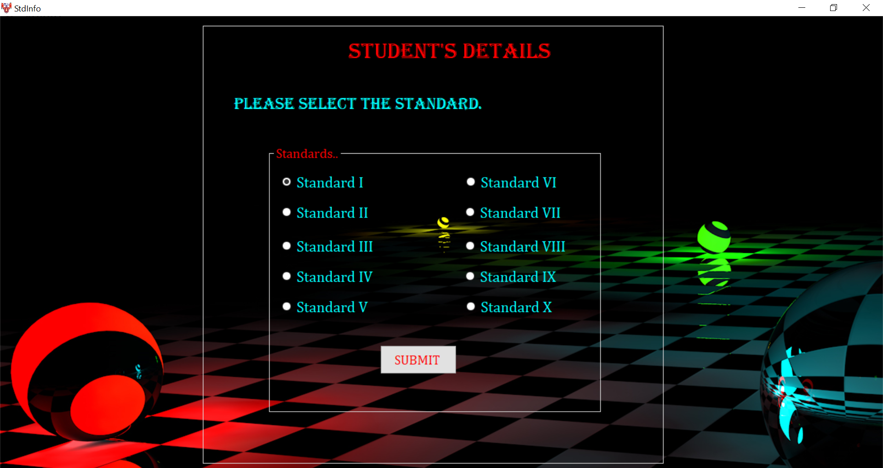

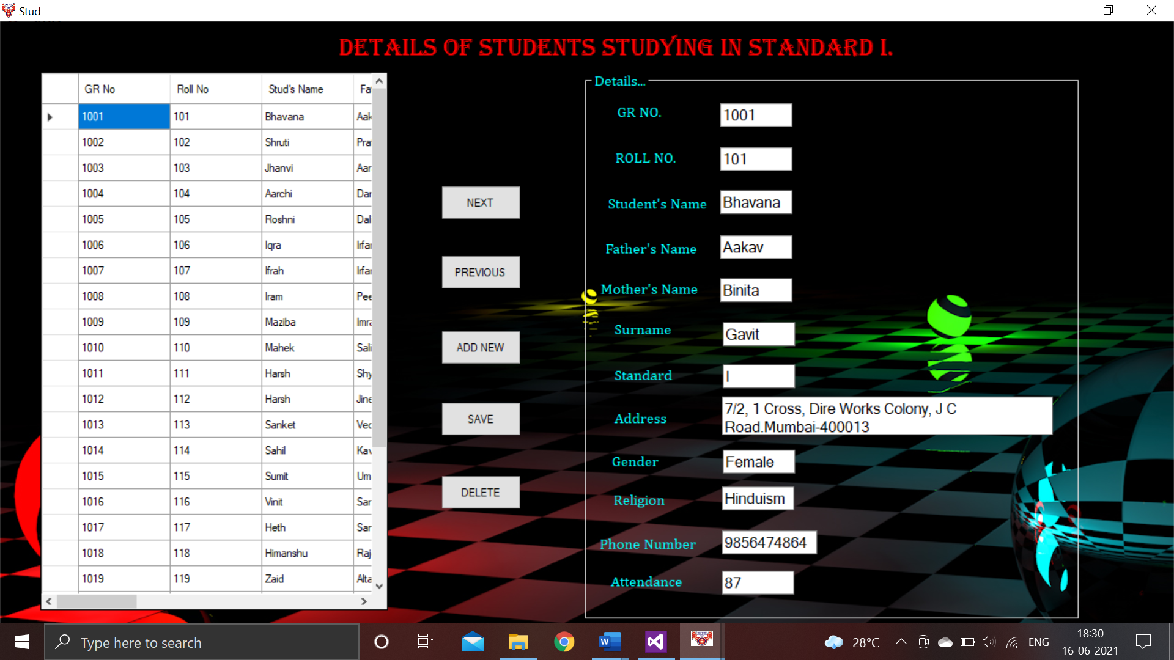

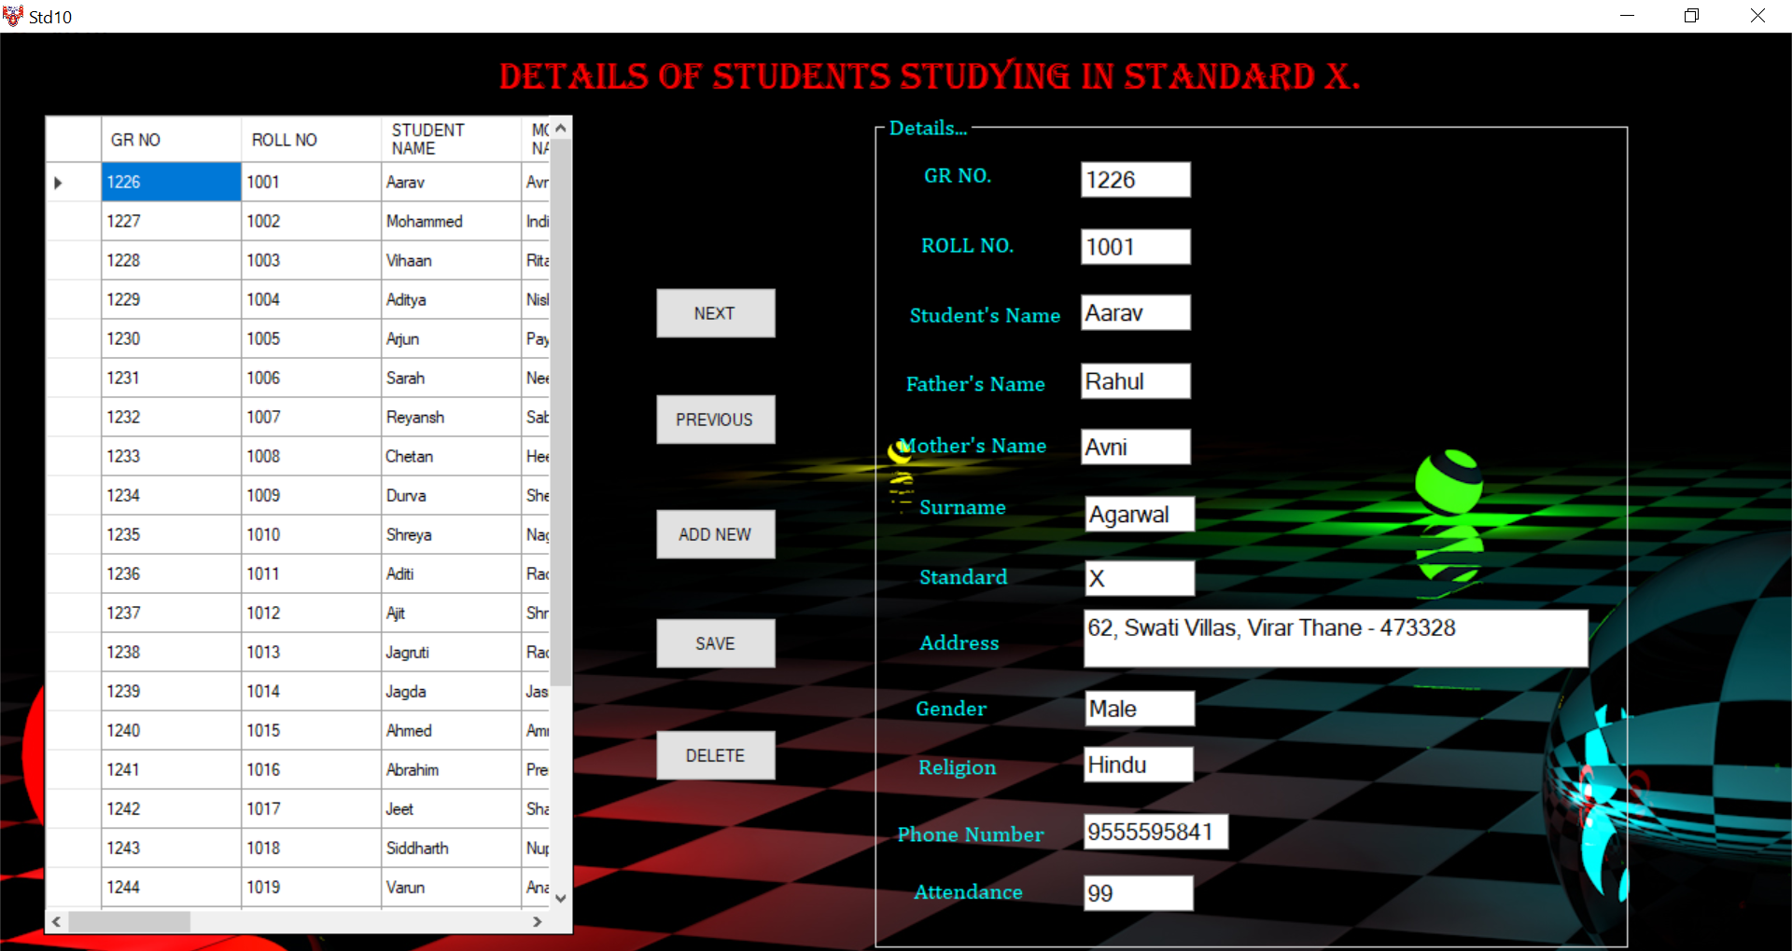

***STAFF INFORMATION FORM: -***

Main Form:

Code:

Public Class StaffInfo

Private Sub StaffInfo_Load(sender As Object, e As EventArgs) Handles MyBase.Load

Me.WindowState = FormWindowState.Maximized

End Sub

Private Sub Button1_Click(sender As Object, e As EventArgs) Handles Button1.Click

If RadioButton1.Checked Then

TeachingStaff.Show()

End If

If RadioButton2.Checked Then

NonTS.Show()

End If

If RadioButton3.Checked Then

Me.Close()

Home.Show()

End If

End Sub

End Class

Output:

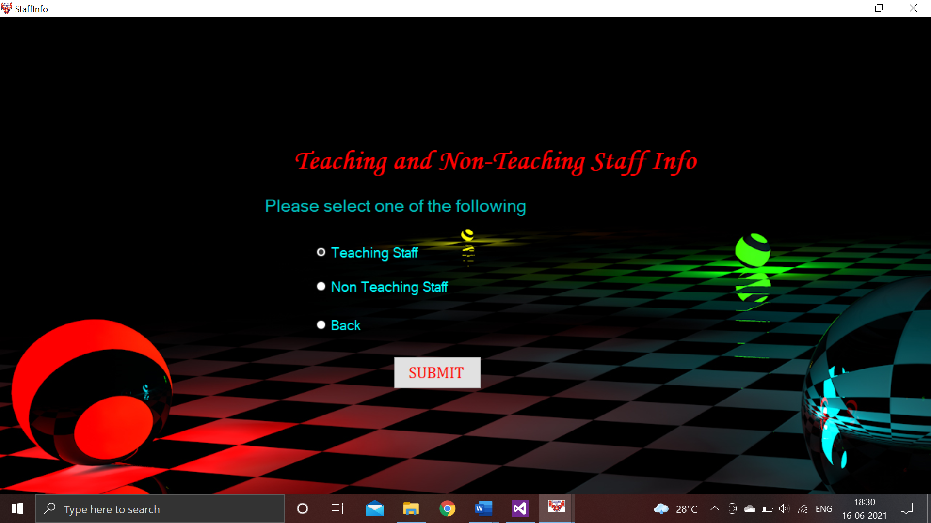

Teaching Staff Form:

Code:

Public Class TeachingStaff

Private Sub TeachingStaff_Load(sender As Object, e As EventArgs) Handles MyBase.Load

Me.WindowState = FormWindowState.Maximized

'TODO: This line of code loads data into the 'TeachingStaffDataSet4.TS' table. You can move, or remove it, as needed.

Me.TSTableAdapter.Fill(Me.TeachingStaffDataSet4.TS)

End Sub

Private Sub Button1_Click(sender As Object, e As EventArgs) Handles Button1.Click

TSBindingSource.MoveNext()

End Sub

Private Sub Button2_Click(sender As Object, e As EventArgs) Handles Button2.Click

TSBindingSource.MovePrevious()

End Sub

Private Sub Button3_Click(sender As Object, e As EventArgs) Handles Button3.Click

TSBindingSource.AddNew()

End Sub

Private Sub Button4_Click(sender As Object, e As EventArgs) Handles Button4.Click

On Error GoTo SaveError

TSBindingSource.EndEdit()

TSTableAdapter.Update(TeachingStaffDataSet4.TS)

MsgBox("Data has been saved")

SaveError:

Exit Sub

End Sub

Private Sub Button5_Click(sender As Object, e As EventArgs) Handles Button5.Click

TSBindingSource.RemoveCurrent()

End Sub

Private Sub Button6_Click(sender As Object, e As EventArgs) Handles Button6.Click

If TextBox9.Text = "" Then

Call notFound()

Exit Sub

Else

TSBindingSource.Filter = "(Convert(SrNo, 'System.String') LIKE '" & TextBox9.Text & "')" & _

"OR (Title LIKE '" & TextBox9.Text & "') OR (FName LIKE '" & TextBox9.Text & "')" & _

"OR (Surname Like '" & TextBox9.Text & "') OR (Convert(PhoneNumber, 'System.String') LIKE '" & TextBox9.Text & "')" & _

"OR (Designation LIKE '" & TextBox9.Text & "') OR (Subjects LIKE '" & TextBox9.Text & "')" & _

"OR (Convert(Experience, 'System.String') LIKE '" & TextBox9.Text & "')"

End If

End Sub

Private Sub notFound()

MsgBox("Enter something. The Search bar is empty! ")

End Sub

End Class

Output:

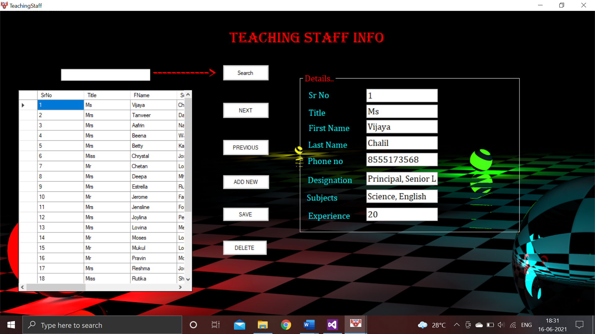

Non-Teaching Staff Form:

Code:

Public Class NonTS

Private Sub NonTS_Load(sender As Object, e As EventArgs) Handles MyBase.Load

Me.WindowState = FormWindowState.Maximized

'TODO: This line of code loads data into the 'NonTeachingStaffDataSet1.NTS' table. You can move, or remove it, as needed.

Me.NTSTableAdapter.Fill(Me.NonTeachingStaffDataSet1.NTS)

End Sub

Private Sub Button1_Click(sender As Object, e As EventArgs) Handles Button1.Click

NTSBindingSource.MoveNext()

End Sub

Private Sub Button2_Click(sender As Object, e As EventArgs) Handles Button2.Click

NTSBindingSource.MovePrevious()

End Sub

Private Sub Button3_Click(sender As Object, e As EventArgs) Handles Button3.Click

NTSBindingSource.AddNew()

End Sub

Private Sub Button5_Click(sender As Object, e As EventArgs) Handles Button5.Click

NTSBindingSource.RemoveCurrent()

End Sub

Private Sub Button4_Click(sender As Object, e As EventArgs) Handles Button4.Click

On Error GoTo SaveError

NTSBindingSource.EndEdit()

NTSTableAdapter.Update(NonTeachingStaffDataSet1.NTS)

MsgBox("Data has been saved")

SaveError:

MsgBox("Please Enter all the Specific Values in the Text Box")

Exit Sub

End Sub

Private Sub Button6_Click(sender As Object, e As EventArgs) Handles Button6.Click

If TextBox9.Text = "" Then

Call notFound()

Exit Sub

Else

NTSBindingSource.Filter = "(Convert(SrNo, 'System.String') LIKE '" & TextBox9.Text & "')" & _

"OR(Title LIKE '" & TextBox9.Text & "' ) OR (FName LIKE '" & TextBox9.Text & "')" & _

"OR(Surname LIKE '" & TextBox9.Text & "' ) OR (Convert(PhoneNumber, 'System.String') LIKE '" & TextBox9.Text & "')" & _

"OR (Designation LIKE '" & TextBox9.Text & "' )"

If NTSBindingSource.Count <> 0 Then

With DataGridView1

.DataSource = NTSBindingSource

End With

Else

MsgBox(" The search item was not found")

NTSBindingSource.Filter = Nothing

End If

End If

End Sub

Private Sub notFound()

MsgBox("Enter something. The search bar is empty!")

End Sub

End Class

Output:

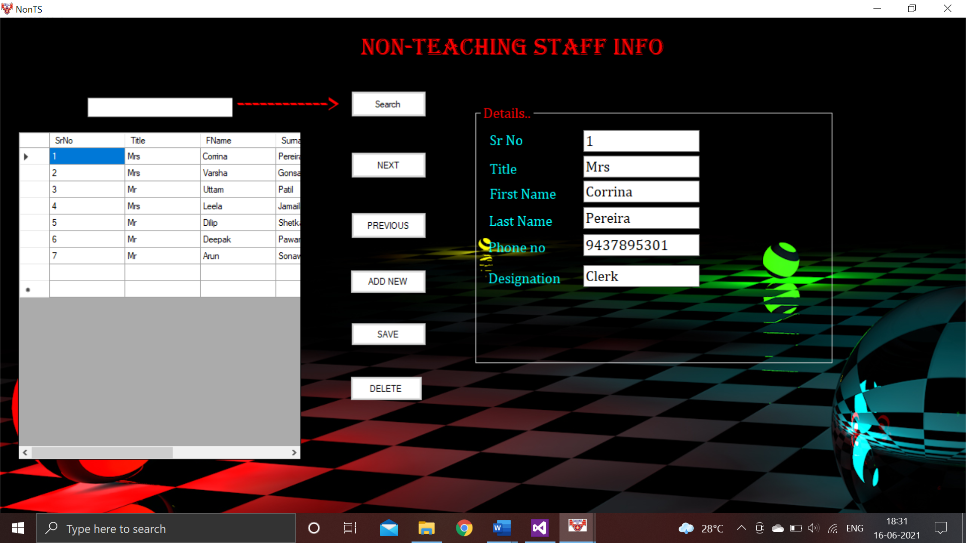

***BLACK LIST FORM: -***

Code:

Imports System.Data.OleDb

Public Class BlackList

Dim cmd As OleDbCommand = New OleDbCommand

Dim conn As OleDbConnection = New OleDbConnection(" Provider=Microsoft.Jet.OLEDB.4.0; Data Source= C:\Users\ARISHA\Documents\BL.mdb;")

Dim adpt As OleDbDataAdapter = New OleDbDataAdapter

Dim ds As New DataSet

Dim str As String

Private Sub BlackList_Load(sender As Object, e As EventArgs) Handles MyBase.Load

Me.WindowState = FormWindowState.Maximized

End Sub

Private Sub Button1_Click(sender As Object, e As EventArgs) Handles Button1.Click

conn.Open()

str = "select * from Std where Standard ='" & TextBox1.Text & "'and Attendance < " & 35 & " "

cmd = New OleDbCommand(str, conn)

adpt = New OleDbDataAdapter(cmd)

adpt.Fill(ds, "Std")

DataGridView1.DataSource = ds

DataGridView1.DataMember = "Std"

DataGridView1.Refresh()

conn.Close()

End Sub

End Class

Output:

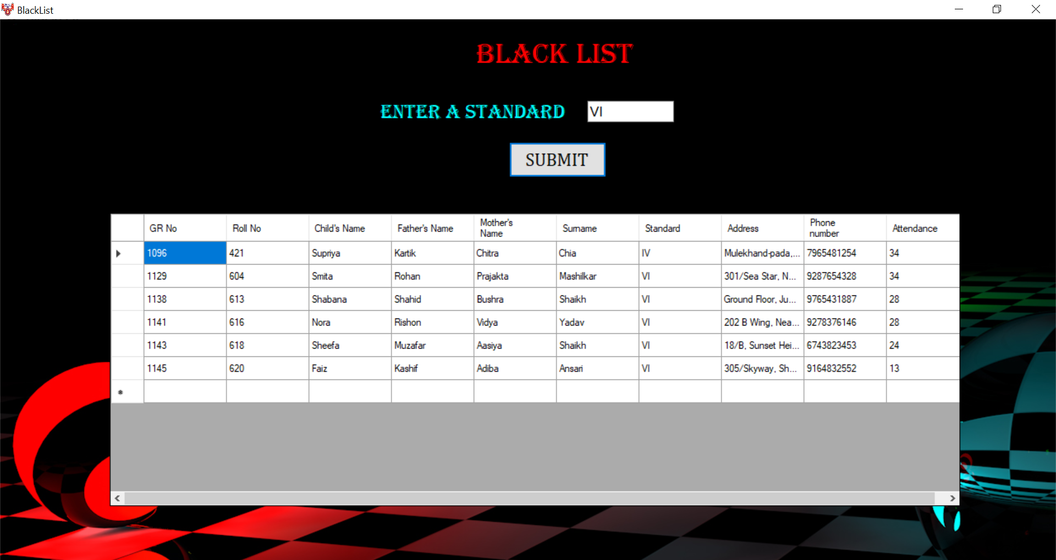

***RESULTS FORM: -***

Main Form:

Code:

Public Class Result

Private Sub R1_Load(sender As Object, e As EventArgs) Handles MyBase.Load

Me.WindowState = FormWindowState.Maximized

End Sub

Private Sub Button1_Click(sender As Object, e As EventArgs) Handles Button1.Click

If RadioButton1.Checked Then

R1.Show()

End If

If RadioButton2.Checked Then

R2.Show()

End If

If RadioButton3.Checked Then

R3.Show()

End If

If RadioButton4.Checked Then

R4.Show()

End If

If RadioButton5.Checked Then

R5.Show()

End If

If RadioButton6.Checked Then

Resultstud.Show()

End If

End Sub

End Class

Output:

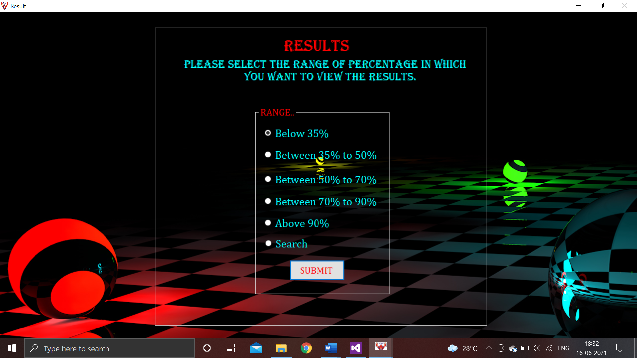

Result below 35% Form:

Code:

Imports System.Data.OleDb

Public Class R1

Dim cmd As OleDbCommand = New OleDbCommand

Dim reader As OleDbDataReader

Dim conn As OleDbConnection = New OleDbConnection

Dim adpt As OleDbDataAdapter = New OleDbDataAdapter

Dim ds As New DataSet

Dim str As String

Private Sub R1_Load(sender As Object, e As EventArgs) Handles MyBase.Load

Me.WindowState = FormWindowState.Maximized

conn = New OleDbConnection("Provider=Microsoft.Jet.OLEDB.4.0; Data Source= C:\Users\ARISHA\OneDrive\Documents\RESULT.mdb;")

conn.Open()

str = "select * from results where (Percentage < 35)"

cmd = New OleDbCommand(str, conn)

adpt = New OleDbDataAdapter(cmd)

adpt.Fill(ds, "results")

DataGridView1.DataSource = ds

DataGridView1.DataMember = "results"

conn.Close()

End Sub

End Class

Output:

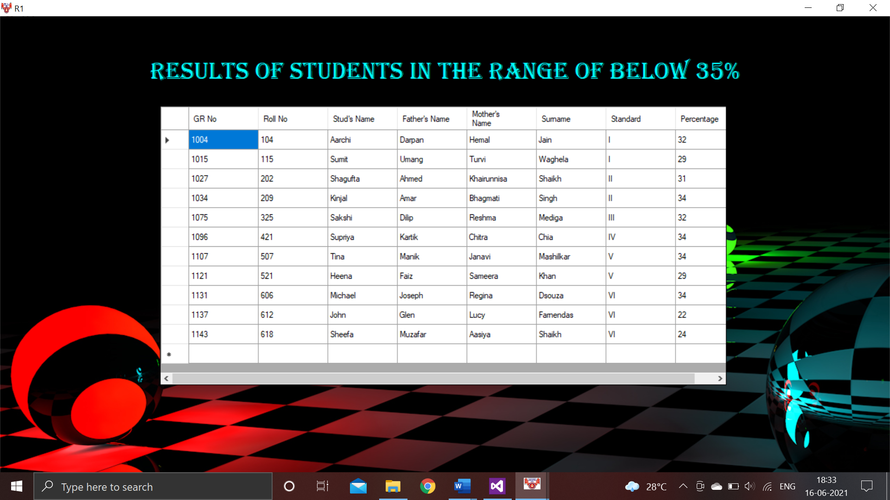

Result between 35% to 50% Form:

Code:

Imports System.Data.OleDb

Public Class R2

Dim cmd As OleDbCommand = New OleDbCommand

Dim reader As OleDbDataReader

Dim conn As OleDbConnection = New OleDbConnection

Dim adpt As OleDbDataAdapter = New OleDbDataAdapter

Dim ds As New DataSet

Dim str As String

Private Sub R2_Load(sender As Object, e As EventArgs) Handles MyBase.Load

Me.WindowState = FormWindowState.Maximized

conn = New OleDbConnection("Provider=Microsoft.Jet.OLEDB.4.0; Data Source= C:\Users\ARISHA\OneDrive\Documents\RESULT.mdb;")

conn.Open()

str = "select * from results where (Percentage between 35 and 50)"

cmd = New OleDbCommand(str, conn)

adpt = New OleDbDataAdapter(cmd)

adpt.Fill(ds, "results")

DataGridView1.DataSource = ds

DataGridView1.DataMember = "results"

conn.Close()

End Sub

End Class

Output:

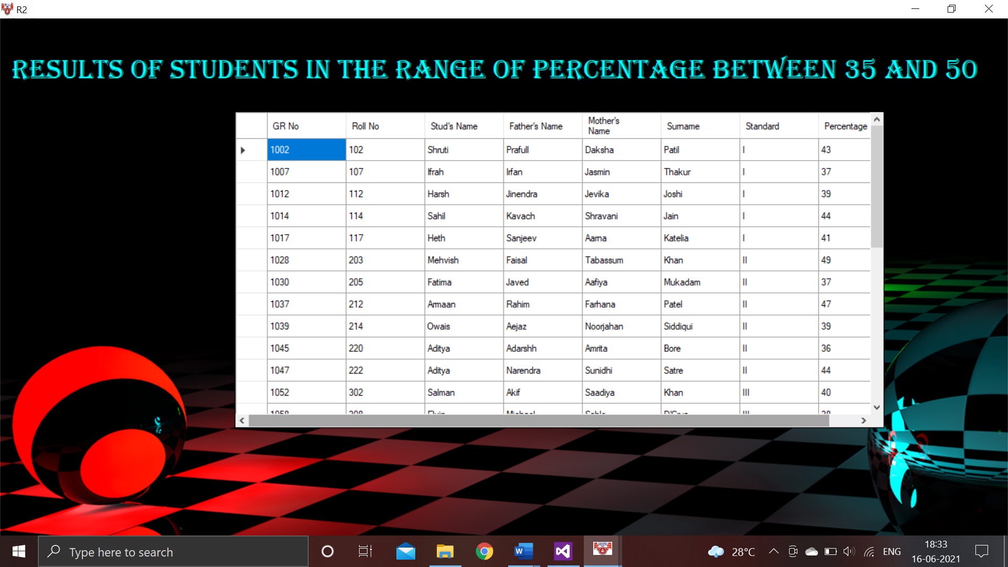

Result between 50% to 70% Form:

Code:

Imports System.Data.OleDb

Public Class R3

Dim cmd As OleDbCommand = New OleDbCommand

Dim reader As OleDbDataReader

Dim conn As OleDbConnection = New OleDbConnection

Dim adpt As OleDbDataAdapter = New OleDbDataAdapter

Dim ds As New DataSet

Dim str As String

Private Sub R3_Load(sender As Object, e As EventArgs) Handles MyBase.Load

Me.WindowState = FormWindowState.Maximized

conn = New OleDbConnection("Provider=Microsoft.Jet.OLEDB.4.0; Data Source= C:\Users\ARISHA\OneDrive\Documents\RESULT.mdb;")

conn.Open()

str = "select * from results where (Percentage between 50 and 70)"

cmd = New OleDbCommand(str, conn)

adpt = New OleDbDataAdapter(cmd)

adpt.Fill(ds, "results")

DataGridView1.DataSource = ds

DataGridView1.DataMember = "results"

conn.Close()

End Sub

End Class

Output:

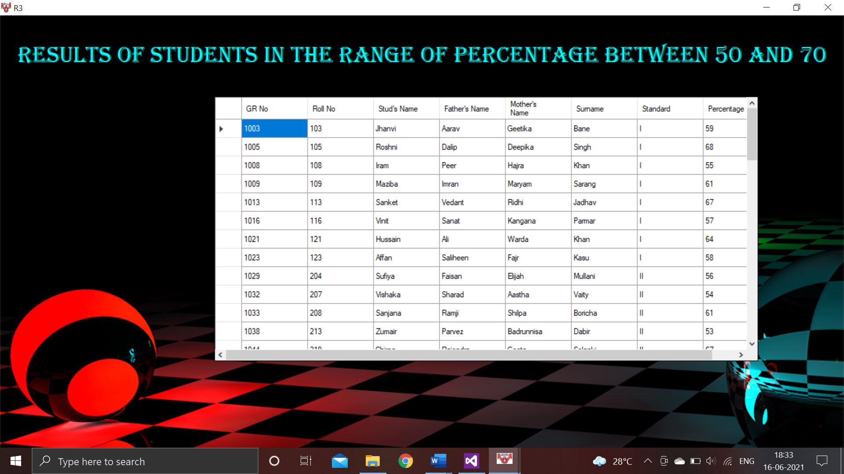

Result between 70% to 90% Form:

Code:

Imports System.Data.OleDb

Public Class R4

Dim cmd As OleDbCommand = New OleDbCommand

Dim reader As OleDbDataReader

Dim conn As OleDbConnection = New OleDbConnection

Dim adpt As OleDbDataAdapter = New OleDbDataAdapter

Dim ds As New DataSet

Dim str As String

Private Sub R4_Load(sender As Object, e As EventArgs) Handles MyBase.Load

Me.WindowState = FormWindowState.Maximized

conn = New OleDbConnection("Provider=Microsoft.Jet.OLEDB.4.0; Data Source= C:\Users\ARISHA\OneDrive\Documents\RESULT.mdb;")

conn.Open()

str = "select * from results where (Percentage between 70 and 90)"

cmd = New OleDbCommand(str, conn)

adpt = New OleDbDataAdapter(cmd)

adpt.Fill(ds, "results")

DataGridView1.DataSource = ds

DataGridView1.DataMember = "results"

conn.Close()

End Sub

End Class

Output:

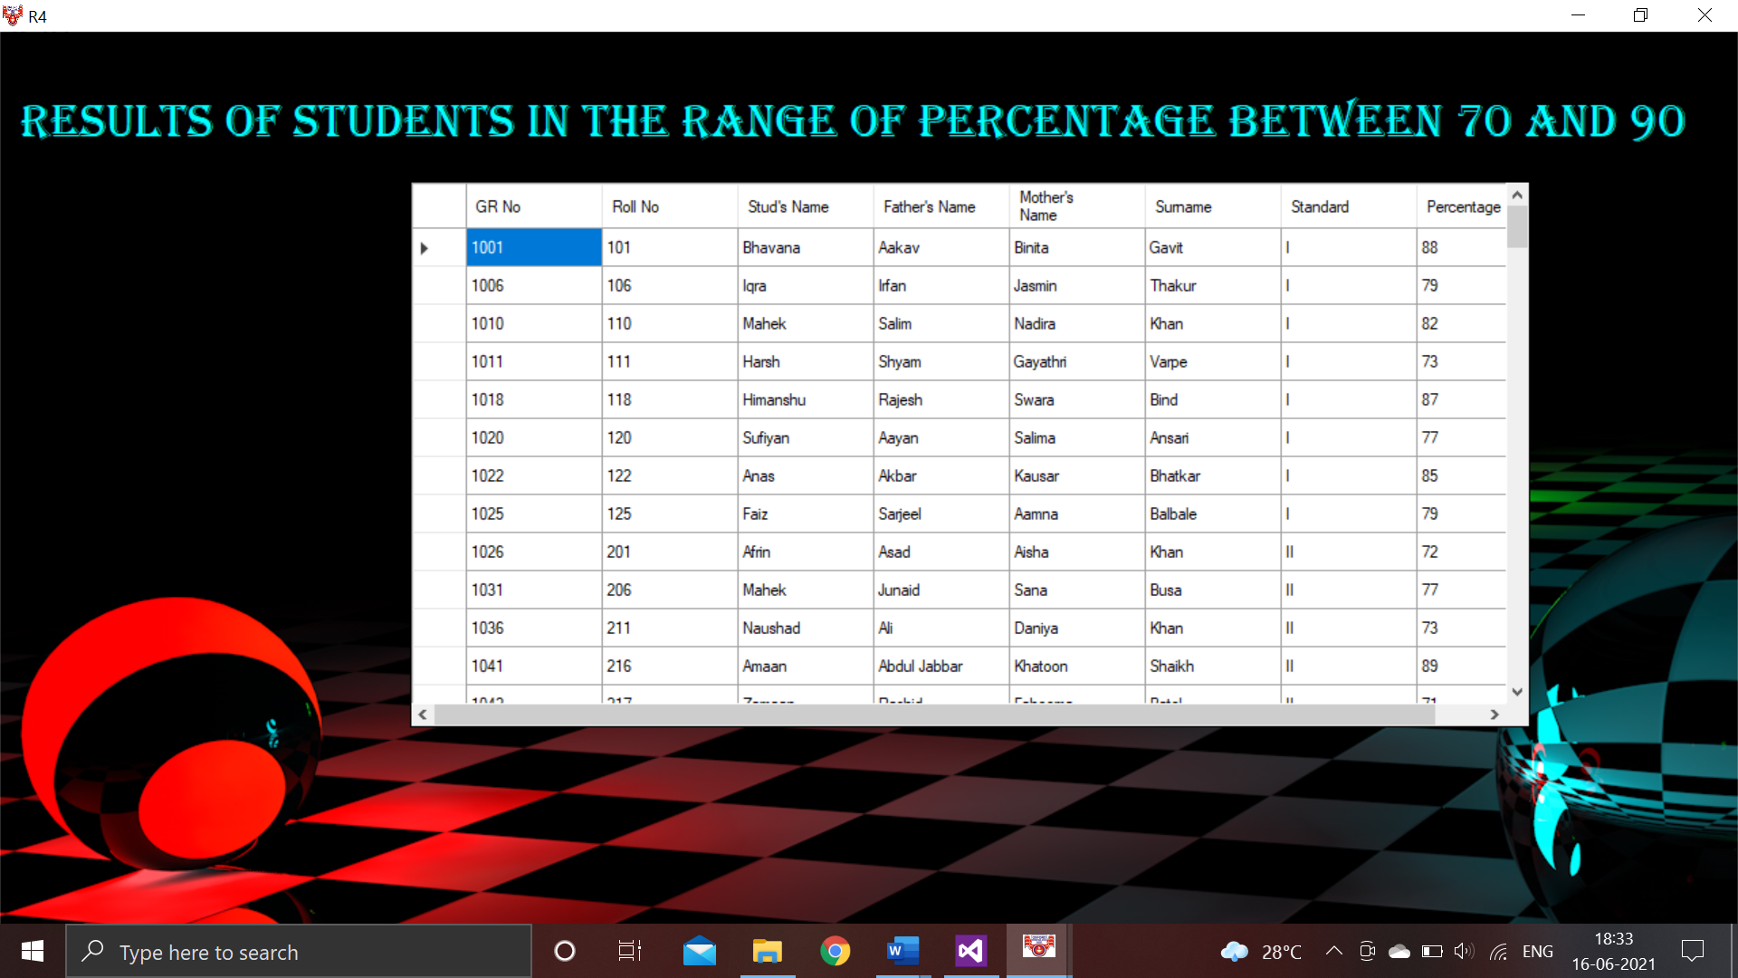

Result above 90% Form:

Code:

Imports System.Data.OleDb

Public Class R5

Dim cmd As OleDbCommand = New OleDbCommand

Dim reader As OleDbDataReader

Dim conn As OleDbConnection = New OleDbConnection

Dim adpt As OleDbDataAdapter = New OleDbDataAdapter

Dim ds As New DataSet

Dim str As String

Private Sub R5_Load(sender As Object, e As EventArgs) Handles MyBase.Load

Me.WindowState = FormWindowState.Maximized

conn = New OleDbConnection("Provider=Microsoft.Jet.OLEDB.4.0; Data Source= C:\Users\ARISHA\OneDrive\Documents\RESULT.mdb;")

conn.Open()

str = "select * from results where (Percentage between 90 and 99)"

cmd = New OleDbCommand(str, conn)

adpt = New OleDbDataAdapter(cmd)

adpt.Fill(ds, "results")

DataGridView1.DataSource = ds

DataGridView1.DataMember = "results"

End Sub

End Class

Output:

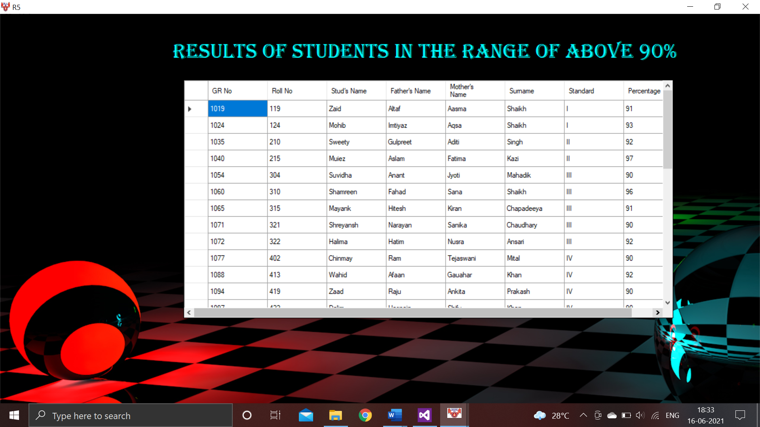

Search a Result of a Particular (Searching Form):

Code:

Imports System.Data.OleDb

Public Class Resultstud

Dim cmd As OleDbCommand = New OleDbCommand

Dim reader As OleDbDataReader

Dim conn As OleDbConnection = New OleDbConnection

Dim adpt As OleDbDataAdapter = New OleDbDataAdapter

Dim ds As New DataSet

Dim str As String

Dim Max As Integer

Private Sub Form3_Load(sender As Object, e As EventArgs) Handles MyBase.Load

Me.WindowState = FormWindowState.Maximized

conn = New OleDbConnection("Provider=Microsoft.Jet.OLEDB.4.0; Data Source= C:\Users\ARISHA\Documents\Res.mdb")

conn.Open()

str = "select * from results"

cmd = New OleDbCommand(str, conn)

adpt = New OleDbDataAdapter(cmd)

adpt.Fill(ds, "results")

DataGridView1.DataSource = ds

DataGridView1.DataMember = "results"

Max = ds.Tables("results").Rows.Count

End Sub

Private Sub Button3_Click(sender As Object, e As EventArgs) Handles Button3.Click

ErrorProvider1.Clear()

ErrorProvider2.Clear()

If TextBox3.Text = "" Then

ErrorProvider1.SetError(TextBox3, "Please Enter Roll No")

ElseIf Not IsNumeric(TextBox3.Text) Then

ErrorProvider2.SetError(TextBox3, "Please Enter Only numberic Values")

Else

DataGridView1.Hide()

GroupBox3.Hide()

GroupBox1.Show()

PictureBox3.Show()

Label1.Show()

Label13.Show()

Label16.Show()

Label18.Show()

Label19.Show()

Label2.Show()

Label20.Show()

Label21.Show()

Label22.Show()

Label23.Show()

Label24.Show()

Label3.Show()

Label4.Show()

Label5.Show()

TextBox24.Show()

TextBox23.Show()

TextBox22.Show()

TextBox1.Show()

TextBox18.Show()

TextBox19.Show()

TextBox20.Show()

TextBox21.Show()

TextBox2.Show()

TextBox16.Show()

Dim a, inc As Integer

inc = 0

A: If inc <> Max Then

a = ds.Tables("results").Rows(inc).Item(1)

If a = Val(TextBox3.Text) Then

TextBox24.Text = ds.Tables("results").Rows(inc).Item(0)

TextBox23.Text = ds.Tables("results").Rows(inc).Item(1)

TextBox22.Text = ds.Tables("results").Rows(inc).Item(2)

TextBox1.Text = ds.Tables("results").Rows(inc).Item(6)

TextBox18.Text = ds.Tables("results").Rows(inc).Item(10)

TextBox19.Text = ds.Tables("results").Rows(inc).Item(9)

TextBox20.Text = ds.Tables("results").Rows(inc).Item(8)

TextBox21.Text = ds.Tables("results").Rows(inc).Item(7)

TextBox2.Text = ds.Tables("results").Rows(inc).Item(12)

TextBox16.Text = ds.Tables("results").Rows(inc).Item(11)

'MsgBox(" Search Succesfull")

GoTo B

End If

inc = inc + 1

GoTo A

End If

B:

conn.Close()

End If

End Sub

End Class

Output:

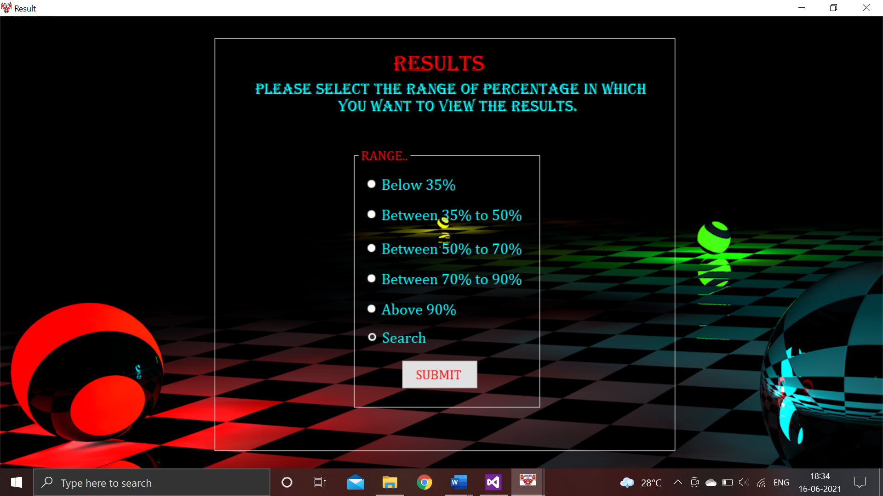

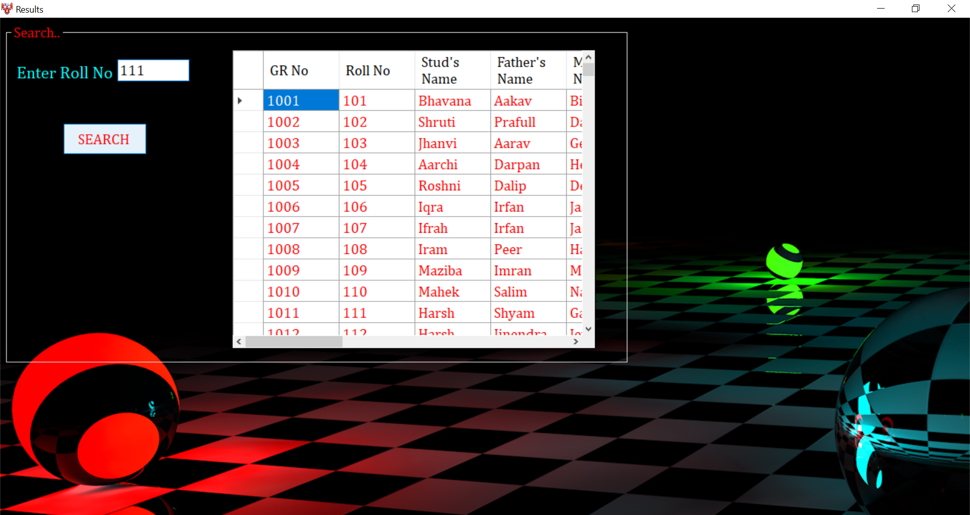

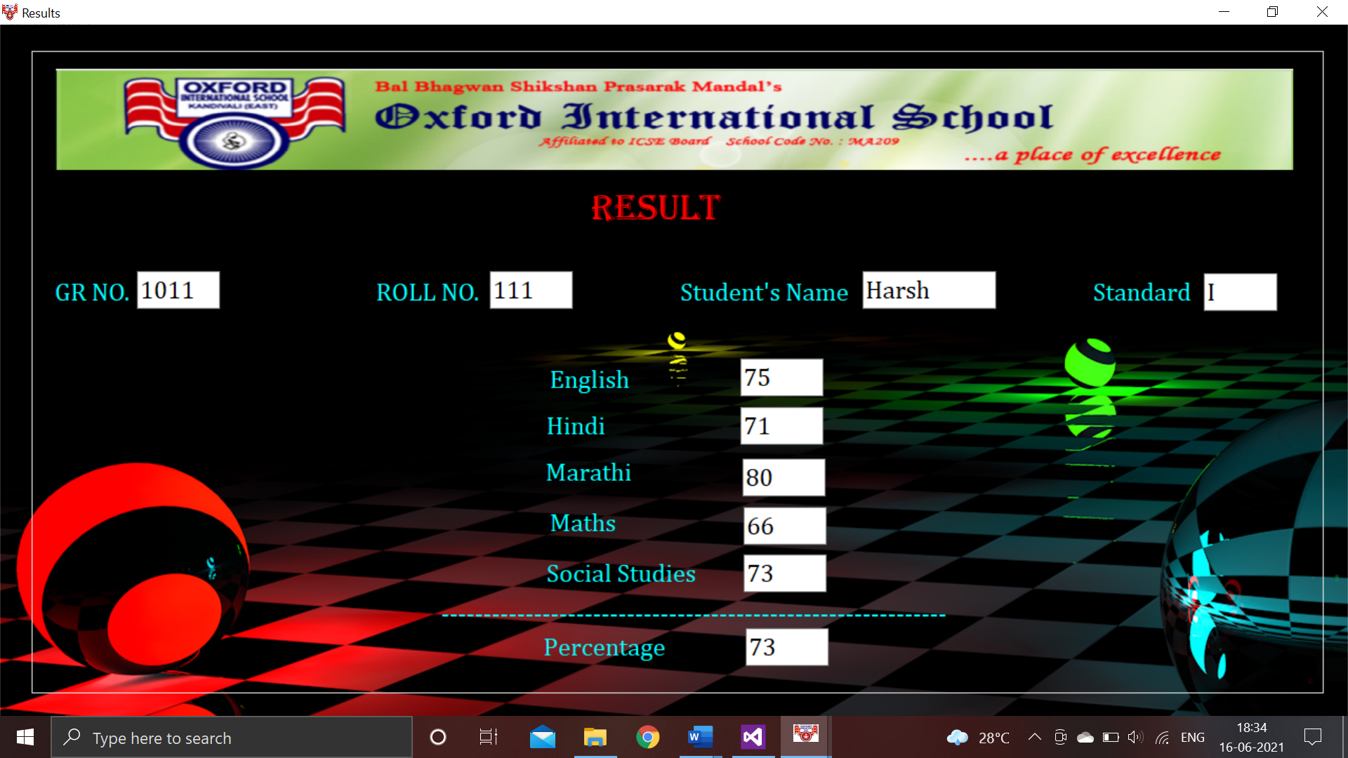

***FEES INFORMATION FORM: -***

Code:

Imports System.Data.OleDb

Public Class Fees

Dim con As OleDbConnection = New OleDbConnection("Provider=Microsoft.Jet.OLEDB.4.0;Data Source=C:\Users\ARISHA\Documents\std 10.mdb")

Dim com1 As OleDbCommand = New OleDbCommand

Dim com11 As OleDbCommand = New OleDbCommand

Dim com2 As OleDbCommand = New OleDbCommand

Dim com22 As OleDbCommand = New OleDbCommand

Dim com3 As OleDbCommand = New OleDbCommand

Dim com33 As OleDbCommand = New OleDbCommand

Dim com4 As OleDbCommand = New OleDbCommand

Dim com44 As OleDbCommand = New OleDbCommand

Dim com5 As OleDbCommand = New OleDbCommand

Dim com55 As OleDbCommand = New OleDbCommand

Dim com6 As OleDbCommand = New OleDbCommand

Dim com66 As OleDbCommand = New OleDbCommand

Dim com7 As OleDbCommand = New OleDbCommand

Dim com77 As OleDbCommand = New OleDbCommand

Dim com8 As OleDbCommand = New OleDbCommand

Dim com88 As OleDbCommand = New OleDbCommand

Dim com9 As OleDbCommand = New OleDbCommand

Dim com99 As OleDbCommand = New OleDbCommand

Dim com10 As OleDbCommand = New OleDbCommand

Dim com100 As OleDbCommand = New OleDbCommand

Dim adpt1 As OleDbDataAdapter = New OleDbDataAdapter

Dim adpt2 As OleDbDataAdapter = New OleDbDataAdapter

Dim adpt3 As OleDbDataAdapter = New OleDbDataAdapter

Dim adpt4 As OleDbDataAdapter = New OleDbDataAdapter

Dim adpt5 As OleDbDataAdapter = New OleDbDataAdapter

Dim adpt6 As OleDbDataAdapter = New OleDbDataAdapter

Dim adpt7 As OleDbDataAdapter = New OleDbDataAdapter

Dim adpt8 As OleDbDataAdapter = New OleDbDataAdapter

Dim adpt9 As OleDbDataAdapter = New OleDbDataAdapter

Dim adpt10 As OleDbDataAdapter = New OleDbDataAdapter

Dim adpt11 As OleDbDataAdapter = New OleDbDataAdapter

Dim adpt22 As OleDbDataAdapter = New OleDbDataAdapter

Dim adpt33 As OleDbDataAdapter = New OleDbDataAdapter

Dim adpt44 As OleDbDataAdapter = New OleDbDataAdapter

Dim adpt55 As OleDbDataAdapter = New OleDbDataAdapter

Dim adpt66 As OleDbDataAdapter = New OleDbDataAdapter

Dim adpt77 As OleDbDataAdapter = New OleDbDataAdapter

Dim adpt88 As OleDbDataAdapter = New OleDbDataAdapter

Dim adpt99 As OleDbDataAdapter = New OleDbDataAdapter

Dim adpt100 As OleDbDataAdapter = New OleDbDataAdapter

Dim ds1 As DataSet = New DataSet

Dim ds2 As DataSet = New DataSet

Dim ds3 As DataSet = New DataSet

Dim ds4 As DataSet = New DataSet

Dim ds5 As DataSet = New DataSet

Dim ds6 As DataSet = New DataSet

Dim ds7 As DataSet = New DataSet

Dim ds8 As DataSet = New DataSet

Dim ds9 As DataSet = New DataSet

Dim ds10 As DataSet = New DataSet

Dim ds11 As DataSet = New DataSet

Dim ds22 As DataSet = New DataSet

Dim ds33 As DataSet = New DataSet

Dim ds44 As DataSet = New DataSet

Dim ds55 As DataSet = New DataSet

Dim ds66 As DataSet = New DataSet

Dim ds77 As DataSet = New DataSet

Dim ds88 As DataSet = New DataSet

Dim ds99 As DataSet = New DataSet

Dim ds100 As DataSet = New DataSet

Private Sub Fees_Load(sender As Object, e As EventArgs) Handles MyBase.Load

Me.WindowState = FormWindowState.Maximized

ComboBox1.Items.Add("FEES PAID")

ComboBox1.Items.Add("FEES NOT PAID")

ComboBox2.Items.Add("STD I")

ComboBox2.Items.Add("STD II")

ComboBox2.Items.Add("STD III")

ComboBox2.Items.Add("STD IV")

ComboBox2.Items.Add("STD V")

ComboBox2.Items.Add("STD VI")

ComboBox2.Items.Add("STD VII")

ComboBox2.Items.Add("STD VIII")

ComboBox2.Items.Add("STD IX")

ComboBox2.Items.Add("STD X")

con.Open()

com1 = New OleDbCommand("select * from Table1 where Fees_Status like 'PAID'", con)

adpt1 = New OleDbDataAdapter(com1)

adpt1.Fill(ds1, "Table1")

com2 = New OleDbCommand("select * from Table2 where Fees_Status like 'PAID'", con)

adpt2 = New OleDbDataAdapter(com2)

adpt2.Fill(ds2, "Table2")

com3 = New OleDbCommand("select * from Table3 where Fees_Status like 'PAID'", con)

adpt3 = New OleDbDataAdapter(com3)

adpt3.Fill(ds3, "Table3")

com4 = New OleDbCommand("select * from Table4 where Fees_Status like 'PAID'", con)

adpt4 = New OleDbDataAdapter(com4)

adpt4.Fill(ds4, "Table4")

com5 = New OleDbCommand("select * from Table5 where Fees_Status like 'PAID'", con)

adpt5 = New OleDbDataAdapter(com5)

adpt5.Fill(ds5, "Table5")

com6 = New OleDbCommand("select * from Table6 where Fees_Status like 'PAID'", con)

adpt6 = New OleDbDataAdapter(com6)

adpt6.Fill(ds6, "Table6")

com7 = New OleDbCommand("select * from Table7 where Fees_Status like 'PAID'", con)

adpt7 = New OleDbDataAdapter(com7)

adpt7.Fill(ds7, "Table7")

com8 = New OleDbCommand("select * from Table8 where Fees_Status like 'PAID'", con)

adpt8 = New OleDbDataAdapter(com8)

adpt8.Fill(ds8, "Table8")

com9 = New OleDbCommand("select * from Table9 where Fees_Status like 'PAID'", con)

adpt9 = New OleDbDataAdapter(com9)

adpt9.Fill(ds9, "Table9")

com10 = New OleDbCommand("select * from Table10 where Fees_Status like 'PAID'", con)

adpt10 = New OleDbDataAdapter(com10)

adpt10.Fill(ds10, "Table10")

com11 = New OleDbCommand("select * from table1 where Fees_Status like 'NOT PAID'", con)

adpt11 = New OleDbDataAdapter(com11)

adpt11.Fill(ds11, "Table1")

com22 = New OleDbCommand("select * from Table2 where Fees_Status like 'NOT PAID'", con)

adpt22 = New OleDbDataAdapter(com22)

adpt22.Fill(ds22, "Table2")

com33 = New OleDbCommand("select * from Table3 where Fees_Status like 'NOT PAID'", con)

adpt33 = New OleDbDataAdapter(com33)

adpt33.Fill(ds33, "Table3")

com44 = New OleDbCommand("select * from Table4 where Fees_Status like 'NOT PAID'", con)

adpt44 = New OleDbDataAdapter(com44)

adpt44.Fill(ds44, "Table4")

com55 = New OleDbCommand("select * from Table5 where Fees_Status like 'NOT PAID'", con)

adpt55 = New OleDbDataAdapter(com55)

adpt55.Fill(ds55, "Table5")

com66 = New OleDbCommand("select * from Table6 where Fees_Status like 'NOT PAID'", con)

adpt66 = New OleDbDataAdapter(com66)

adpt66.Fill(ds66, "Table6")

com77 = New OleDbCommand("select * from Table7 where Fees_Status like 'NOT PAID'", con)

adpt77 = New OleDbDataAdapter(com77)

adpt77.Fill(ds77, "Table7")

com88 = New OleDbCommand("select * from Table8 ", con)

adpt88 = New OleDbDataAdapter(com88)

adpt88.Fill(ds88, "Table8")

com99 = New OleDbCommand("select * from Table9 where Fees_Status like 'NOT PAID'", con)

adpt99 = New OleDbDataAdapter(com99)

adpt99.Fill(ds99, "Table9")

com100 = New OleDbCommand("select * from Table10 where Fees_Status like 'NOT PAID'", con)

adpt100 = New OleDbDataAdapter(com100)

adpt100.Fill(ds100, "Table10")

con.Close()

End Sub

Private Sub Button1_Click(sender As Object, e As EventArgs) Handles Button1.Click

con.Open()

If ComboBox1.Text = "FEES PAID" And ComboBox2.Text = "STD I" Then

DataGridView1.DataSource = ds1

DataGridView1.DataMember = "Table1"

ElseIf ComboBox1.Text = "FEES NOT PAID" And ComboBox2.Text = "STD I" Then

DataGridView1.DataSource = ds11

DataGridView1.DataMember = "Table1"

ElseIf ComboBox1.Text = "FEES PAID" And ComboBox2.Text = "STD II" Then

DataGridView1.DataSource = ds2

DataGridView1.DataMember = "Table2"

ElseIf ComboBox1.Text = "FEES NOT PAID" And ComboBox2.Text = "STD II" Then

DataGridView1.DataSource = ds22

DataGridView1.DataMember = "Table2"

ElseIf ComboBox1.Text = "FEES PAID" And ComboBox2.Text = "STD III" Then

DataGridView1.DataSource = ds3

DataGridView1.DataMember = "Table3"

ElseIf ComboBox1.Text = "FEES NOT PAID" And ComboBox2.Text = "STD III" Then

DataGridView1.DataSource = ds3

DataGridView1.DataMember = "Table3"

ElseIf ComboBox1.Text = "FEES PAID" And ComboBox2.Text = "STD IV" Then

DataGridView1.DataSource = ds4

DataGridView1.DataMember = "Table4"

ElseIf ComboBox1.Text = "FEES NOT PAID" And ComboBox2.Text = "STD IV" Then

DataGridView1.DataSource = ds44

DataGridView1.DataMember = "Table4"

ElseIf ComboBox1.Text = "FEES PAID" And ComboBox2.Text = "STD V" Then

DataGridView1.DataSource = ds5

DataGridView1.DataMember = "Table5"

ElseIf ComboBox1.Text = "FEES NOT PAID" And ComboBox2.Text = "STD V" Then

DataGridView1.DataSource = ds55

DataGridView1.DataMember = "Table5"

ElseIf ComboBox1.Text = "FEES PAID" And ComboBox2.Text = "STD VI" Then

DataGridView1.DataSource = ds6

DataGridView1.DataMember = "Table6"

ElseIf ComboBox1.Text = "FEES NOT PAID" And ComboBox2.Text = "STD II" Then

DataGridView1.DataSource = ds66

DataGridView1.DataMember = "Table6"

ElseIf ComboBox1.Text = "FEES PAID" And ComboBox2.Text = "STD VII" Then

DataGridView1.DataSource = ds7

DataGridView1.DataMember = "Table7"

ElseIf ComboBox1.Text = "FEES NOT PAID" And ComboBox2.Text = "STD VII" Then

DataGridView1.DataSource = ds77

DataGridView1.DataMember = "Table7"

ElseIf ComboBox1.Text = "FEES PAID" And ComboBox2.Text = "STD VIII" Then

DataGridView1.DataSource = ds8

DataGridView1.DataMember = "Table8"

ElseIf ComboBox1.Text = "FEES NOT PAID" And ComboBox2.Text = "STD VIII" Then

DataGridView1.DataSource = ds88

DataGridView1.DataMember = "Table8"

ElseIf ComboBox1.Text = "FEES PAID" And ComboBox2.Text = "STD IX" Then

DataGridView1.DataSource = ds9

DataGridView1.DataMember = "Table9"

ElseIf ComboBox1.Text = "FEES NOT PAID" And ComboBox2.Text = "STD IX" Then

DataGridView1.DataSource = ds99

DataGridView1.DataMember = "Table9"

ElseIf ComboBox1.Text = "FEES PAID" And ComboBox2.Text = "STD X" Then

DataGridView1.DataSource = ds10

DataGridView1.DataMember = "Table10"

ElseIf ComboBox1.Text = "FEES NOT PAID" And ComboBox2.Text = "STD X" Then

DataGridView1.DataSource = ds100

DataGridView1.DataMember = "Table10"

End If

con.Close()

End Sub

End Class

Output:

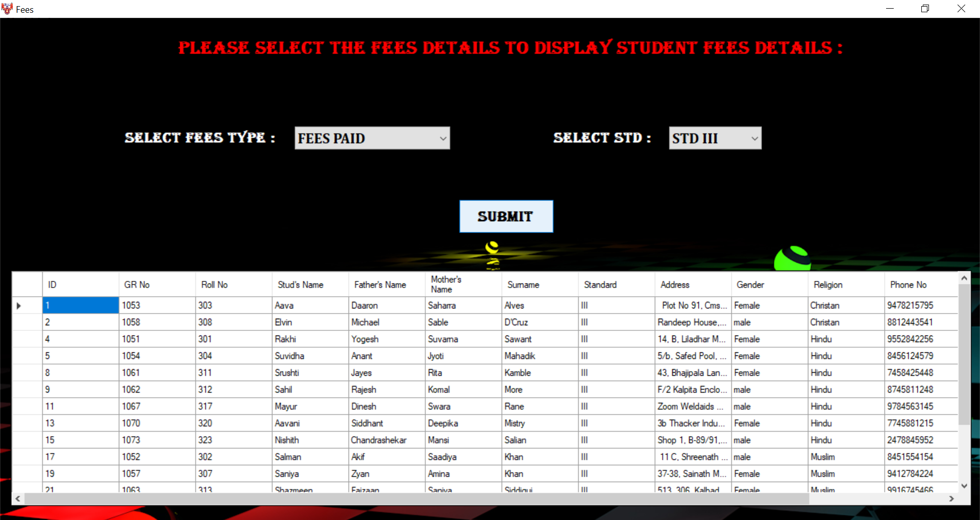

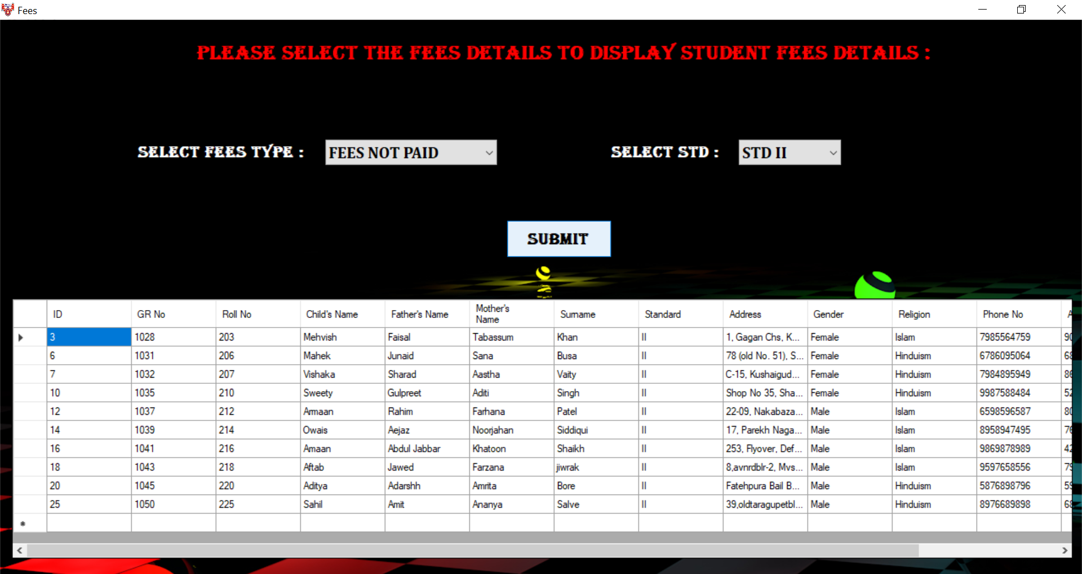

***FEES PAYMENT FORM: -***

Code:

Imports System.Data.OleDb

Public Class FeesPayment

Dim conn As OleDbConnection = New OleDbConnection

Dim cmd As OleDbCommand = New OleDbCommand

Private Sub FeesPayment_Load(sender As Object, e As EventArgs) Handles MyBase.Load

Me.WindowState = FormWindowState.Maximized

conn = New OleDbConnection("provider=Microsoft.Jet.Oledb.4.0;data source=C:\Users\ARISHA\Documents\feespayment.mdb")

End Sub

Private Sub Button2_Click(sender As Object, e As EventArgs) Handles Button2.Click

If TextBox1.Text = "" Or TextBox2.Text = "" Or TextBox3.Text = "" Then

If TextBox1.Text = "" Then

ErrorProvider1.SetError(TextBox1, "enter your name")

TextBox1.Focus()

End If

If TextBox2.Text = "" Then

ErrorProvider2.SetError(TextBox2, "enter your GR.NO")

TextBox2.Focus()

End If

If TextBox3.Text = "" Then

ErrorProvider3.SetError(TextBox3, "enter your Roll.no")

TextBox2.Focus()

End If

End If

If IsNumeric(TextBox1.Text) Or Not IsNumeric(TextBox2.Text) Or Not IsNumeric(TextBox3.Text) Then

If IsNumeric(TextBox1.Text) Then

ErrorProvider1.SetError(TextBox1, "Input alphabets")

End If

If Not IsNumeric(TextBox2.Text) Then

ErrorProvider2.SetError(TextBox2, "Input numbers")

End If

If Not IsNumeric(TextBox3.Text) Then

ErrorProvider3.SetError(TextBox2, "Input numbers")

End If

Else

conn.Open()

Dim str As String

Dim count As Integer

str = "insert into Table1 values('" & TextBox1.Text & "','" & TextBox2.Text & "','" & TextBox3.Text & "','" & ComboBox1.Text & "','" & TextBox4.Text & "')"

cmd = New OleDbCommand(str, conn)

count = cmd.ExecuteNonQuery()

MsgBox("PAYEMENT IS SUCCESSFULLY DONE")

conn.Close()

End If

End Sub

Private Sub Button1_Click(sender As Object, e As EventArgs)

MsgBox("OTP has been Send to Your Registered Mobile Number With Your Respective Bank")

End Sub

End Class

Output:

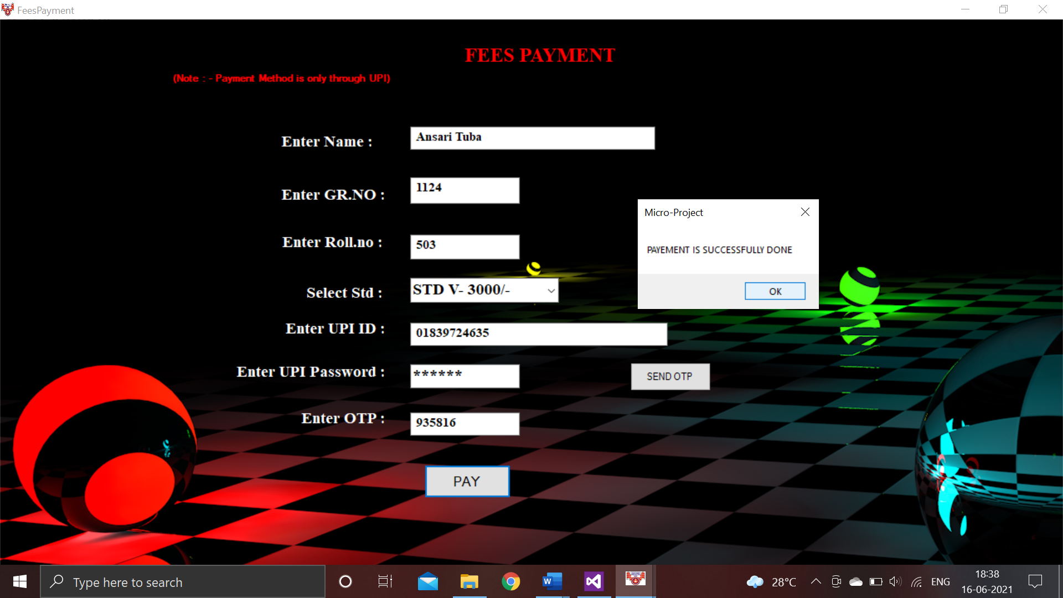

***COMPLAINT FORM: -***

Code:

Public Class Complaint

Dim com As String

Dim gmail As String

Dim pass As String

Private Sub Form1_Load(sender As Object, e As EventArgs) Handles MyBase.Load

'Me.FormBorderStyle = Windows.Forms.FormBorderStyle.None

Me.WindowState = FormWindowState.Maximized

Panel1.Location = New Point(200, 140)

Label6.Location = New Point(870, 130)

Label7.Location = New Point(850, 170)

Label7.Visible = False

Label6.Visible = False

End Sub

Private Sub Button1_Click(sender As Object, e As EventArgs) Handles Button1.Click

If TextBox2.Text = "" Then

MsgBox("Plz enter something", 0, "Exception e")

Else

MsgBox("Your complaint Registered Successfully", 0, "Complaint form")

End If

com = TextBox2.Text

Label7.Text = com

TextBox2.Text = ""

End Sub

Private Sub Label8_Click(sender As Object, e As EventArgs) Handles Label8.Click

gmail = InputBox("Plz enter your Gmail for verification")

pass = InputBox("Plz enter your password for verification")

If gmail = "Anonymous@gmail.com" And pass = "I KNOW I M AWESOME" Then

Label7.Visible = True

Label6.Visible = True

Else

MsgBox("Invalid username or password", 0, "Verification process")

End If

End Sub

Private Sub Button2_Click(sender As Object, e As EventArgs)

Me.Close()

End Sub

End Class

Output:

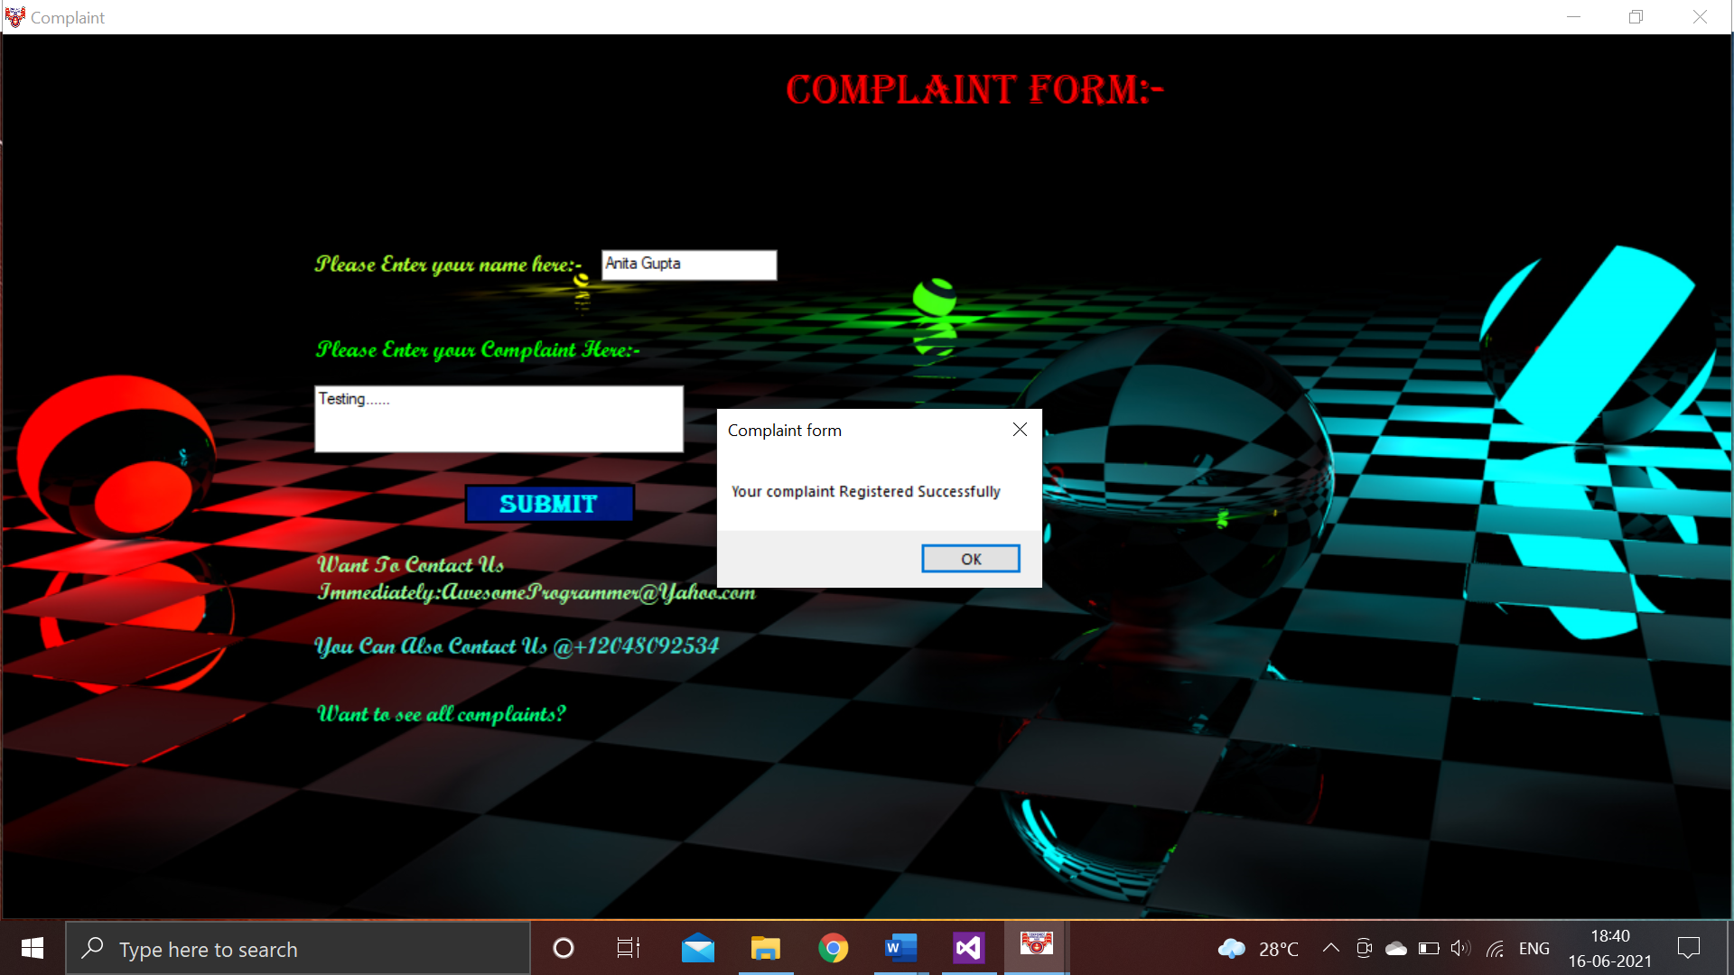

To view the complaint of all users:

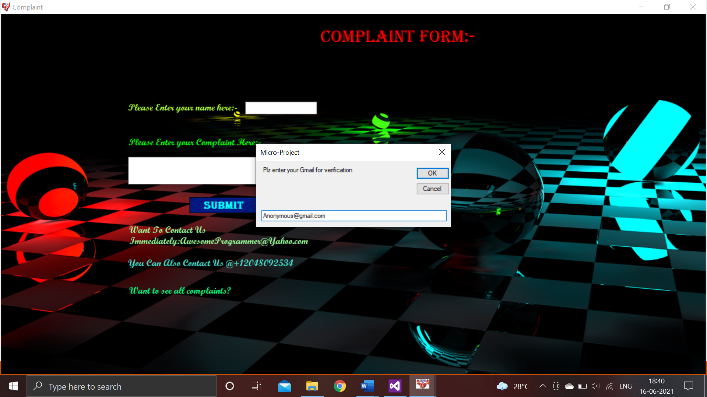

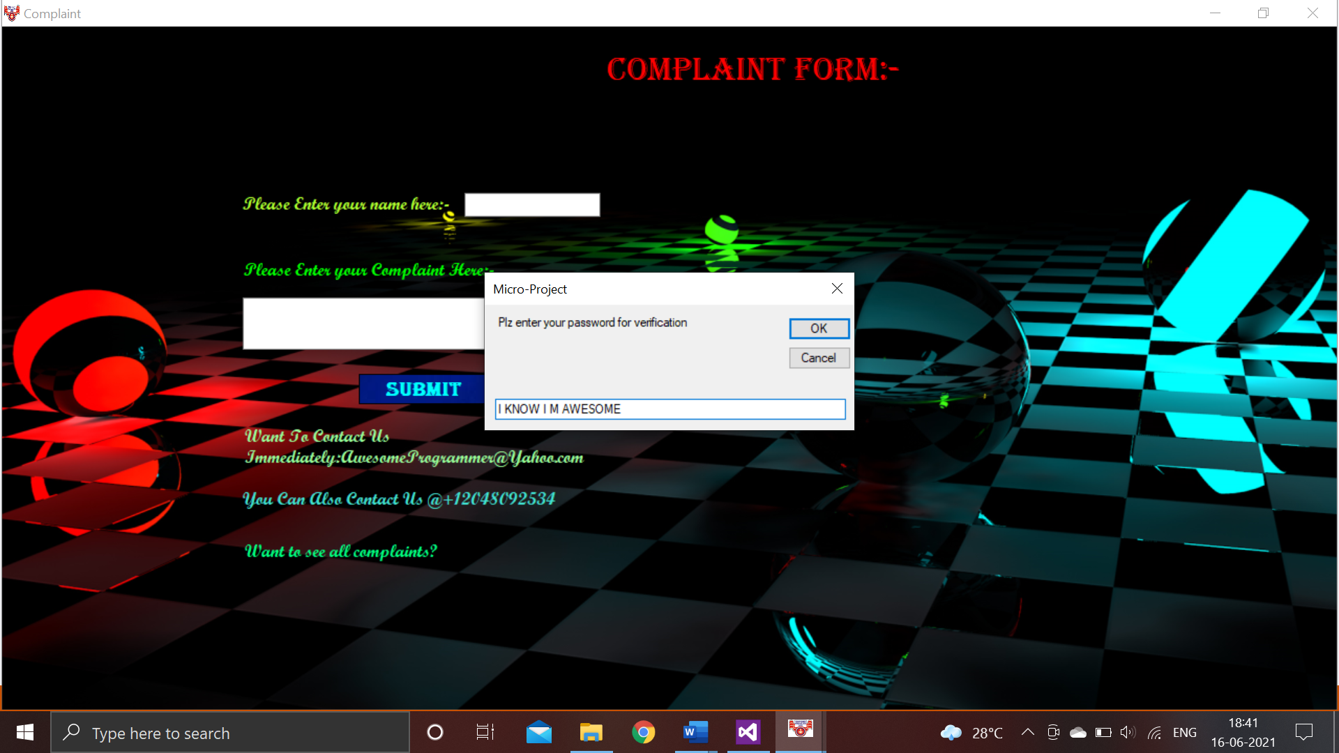

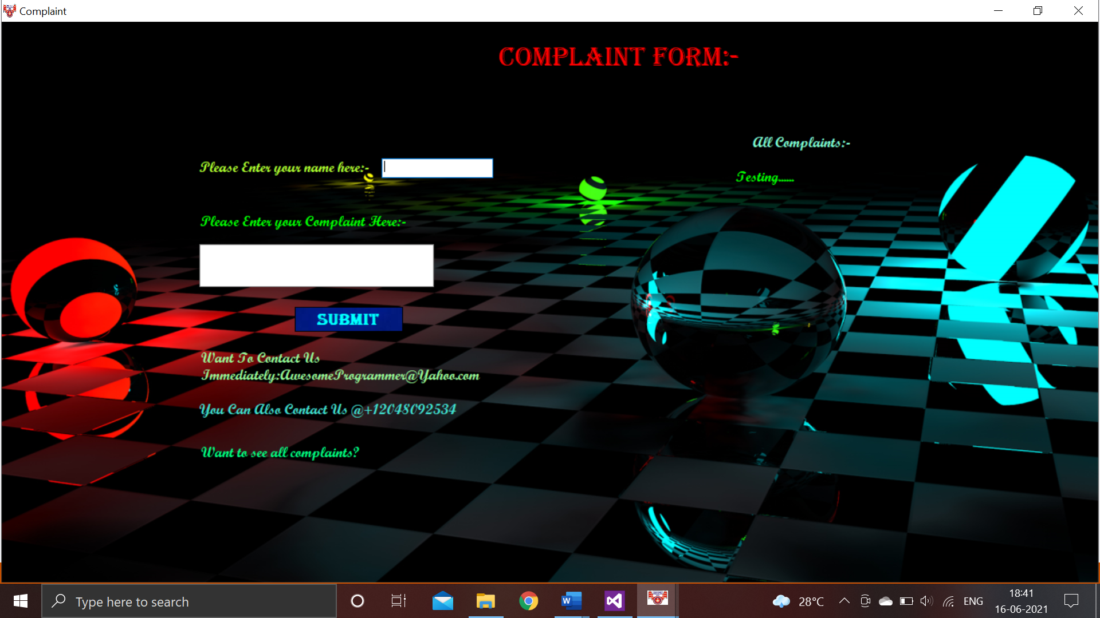

***FEEDBACK FORM: -***

Code:

Imports System.Data.OleDb

Public Class Feedback

Dim conn As OleDbConnection = New OleDbConnection

Dim cmd As OleDbCommand = New OleDbCommand

Private Sub Feedback_Load(sender As Object, e As EventArgs) Handles MyBase.Load

Me.WindowState = FormWindowState.Maximized

conn = New OleDbConnection("provider=Microsoft.Jet.OLEDB.4.0;data source= C:\Users\ARISHA\Documents\feedback.mdb")

End Sub

Private Sub Button1_Click(sender As Object, e As EventArgs) Handles Button1.Click

If TextBox1.Text = "" Or TextBox2.Text = "" Then

If TextBox1.Text = "" Then

ErrorProvider1.SetError(TextBox1, "enter your name")

TextBox1.Focus()

ElseIf TextBox2.Text = "" Then

ErrorProvider2.SetError(TextBox2, "enter your roll.no")

TextBox2.Focus()

End If

End If

If IsNumeric(TextBox1.Text) Or Not IsNumeric(TextBox2.Text) Then

If IsNumeric(TextBox1.Text) Then

ErrorProvider3.SetError(TextBox1, "Input alphabets")

ElseIf Not IsNumeric(TextBox2) Then

ErrorProvider4.SetError(TextBox2, "Input numbers")

End If

Else

conn.Open()

Dim str As String

Dim count As Integer

str = "insert into feedback values('" & TextBox1.Text & "','" & TextBox2.Text & "','" & ComboBox1.Text & "','" & ComboBox2.Text & "','" & ComboBox3.Text & "','" & ComboBox4.Text & "','" & ComboBox5.Text & "','" & ComboBox6.Text & "','" & ComboBox7.Text & "','" & ComboBox8.Text & "','" & TextBox3.Text & "')"

cmd = New OleDbCommand(str, conn)

count = cmd.ExecuteNonQuery()

MsgBox("THANK YOU FOR YOUR FEEDBACK")

Home.Show()

conn.Close()

End If

End Sub

Private Sub TextBox1_TextChanged(sender As Object, e As EventArgs) Handles TextBox1.TextChanged

End Sub

End Class

Output:

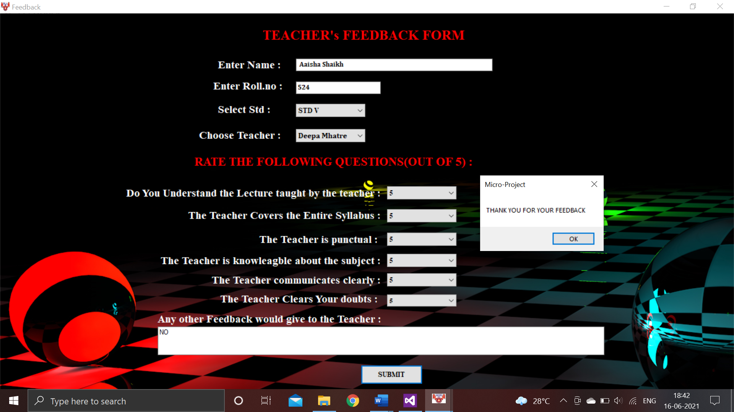

***EXIT FORM: -***

Code:

Public Class h

Private Sub E_Load(sender As Object, e As EventArgs) Handles MyBase.Load

Me.WindowState = FormWindowState.Maximized

End Sub

Private Sub Button2_Click(sender As Object, e As EventArgs)

Home.Show()

End Sub

Private Sub Button1_Click(sender As Object, e As EventArgs) Handles Button1.Click

MsgBox("THANK YOU!!!")

Me.Close()

Home.Close()

Login.Show()

End Sub

Private Sub Button2_Click_1(sender As Object, e As EventArgs) Handles Button2.Click

Me.Close()

Home.Show()

End Sub

End Class

Output:

By pressing no you will come to home page:

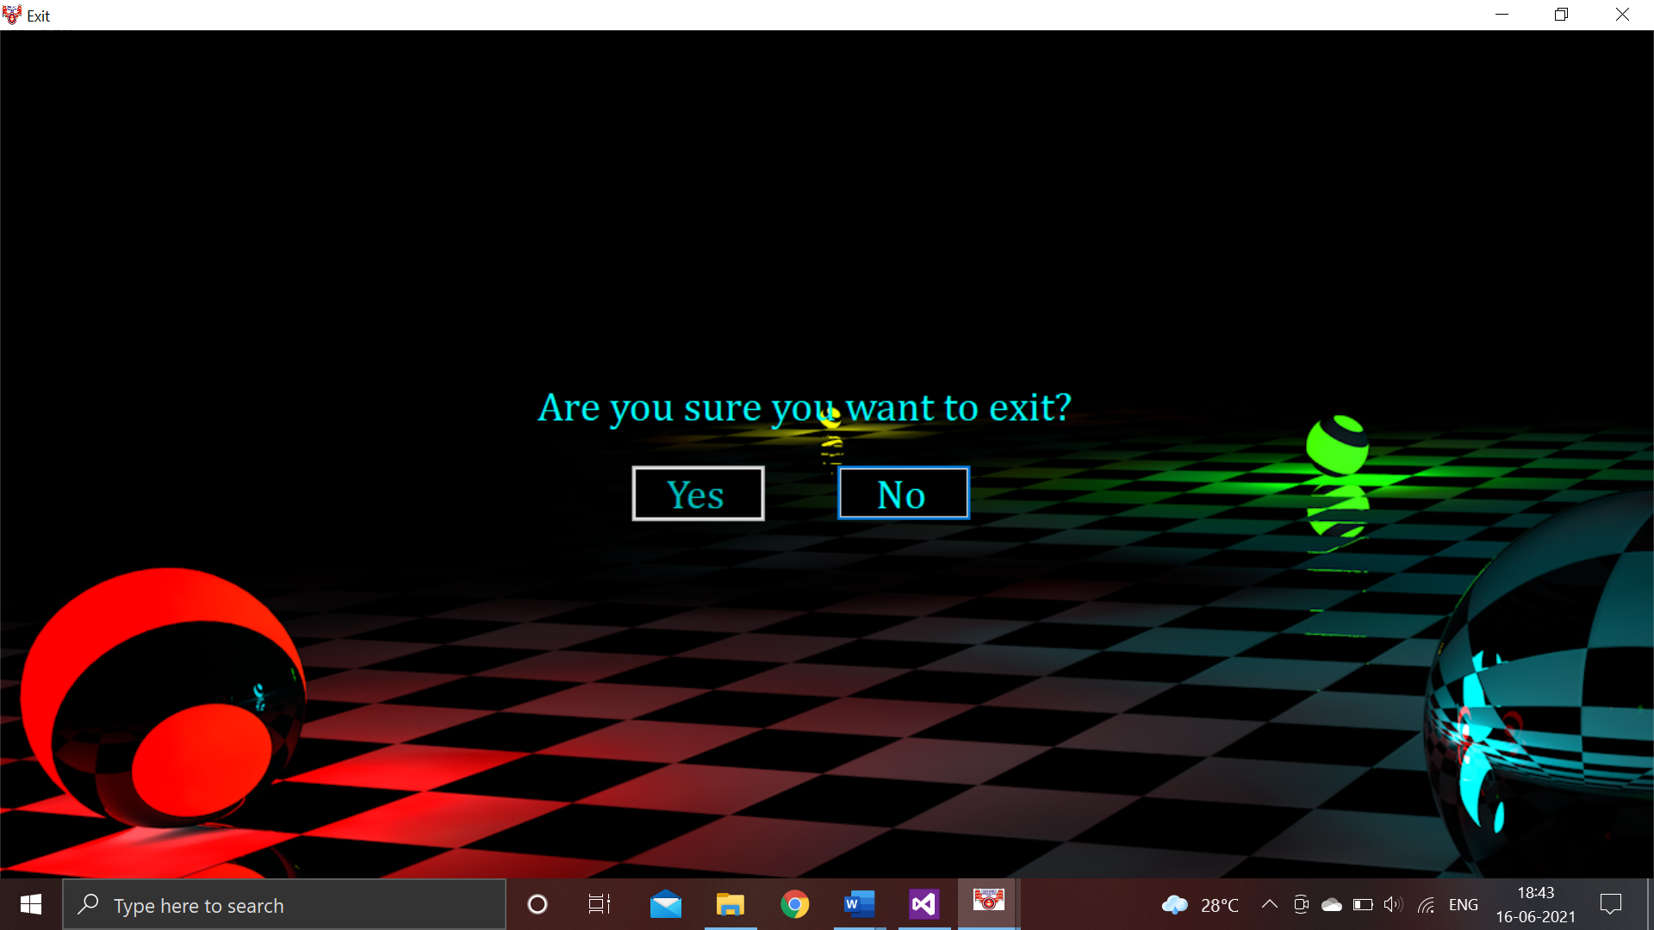

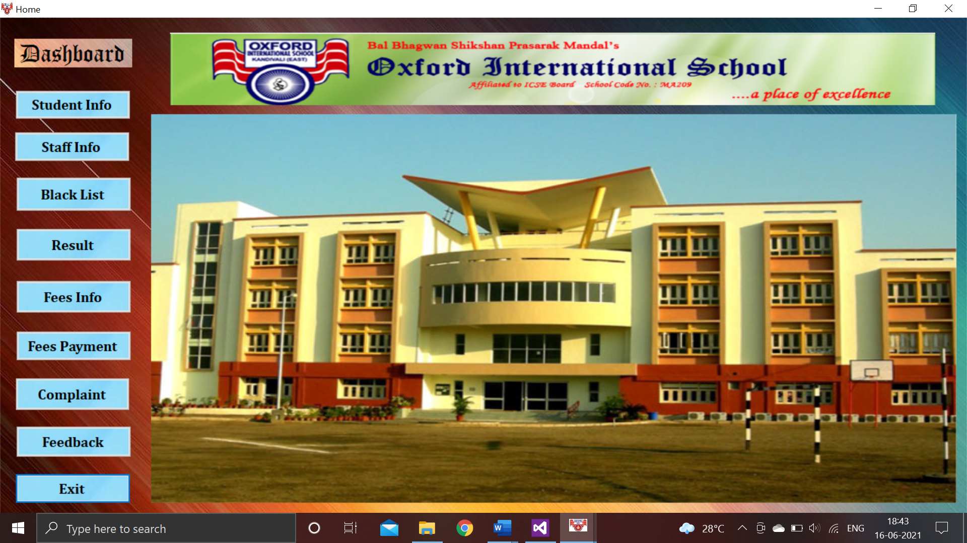

By pressing YES you will exit:

